**MY457 – Causal Inference for Observational and Experimental Studies**

**Lecture 1 – Introduction**

**This course is primarily about *effects of causes***

* D -> Y
* **How do the values of an outcome variable (Y) change when a treatment variable (D) takes on different values?**
* For simplicity we can most of the time focus on the case where the treatment has two values ‘active treatment’ and ‘control treatment,’ or just treatment (1) and control (0).
* We don’t really consider *causes of effects*, or as LSE students say: *rerum cognoscere causas,* orsubstantive explanations of causal mechanisms: *why* a treatment has the effect it does, or prediction.
* How to study causal effects
  + Concepts, definitions, and theoretical foundations
  + Research designs
  + Implementation of these designs
  + Examples and exercises
* Formal technique presentation in places, but that is not the main point
* Only cases where measurement is numerical
* What this course is **not** (primarily) about:
  + Measurement (will feature)
  + Description

Ten two-hour lectures, Wednesdays 12–14.

Five two-hour computer classes (two groups): Thursdays 13–15 and 15–17.

Daniel’s office hours: See the times and make bookings via Student Hub

Assessment for MY457 (MSc) will be a two-hour written examination in the ST (100%)

Lecture slides (before the lecture)

Lecture recordings (after the lecture)

Information about weekly readings

Computer classes: Instructions, code, data

Formative homework assignments: Instructions and answers

**The Potential Outcomes Framework**

*“If a person eats of a particular dish, and dies in consequence, that is, would not have died if he had not eaten of it, people would be apt to say that eating of that dish was the cause of his death.”* — John Stuart Mill, 1843 A System of Logic, Book III

The above quote is based on *counterfactual reasoning*, thinking about whether they would have died if they hadn’t eaten it, a simulation alternative reality. In Neyman’s urn, both the actual and counterfactual realities exist for each observation.

This lecture, we will look at:

1. Potential outcomes
2. Causal Estimands
3. Identification
4. Assignment mechanisms
5. Summary

**Notation**

* Treatment is going to be indicated in this class with D. For each observation, it is Di. D can either be a 1 (treatment) or 0 (control).
  + Treatment = D
* Yi is the observed outcome variable of interest for unit i.
  + Observed Outcome = Yi
  + Outside the urn
* Y0i and Y1i are potential outcomes for unit i.
  + Potential outcomes = Y0i and Y1i
  + Inside the urn

We can connect these three concepts mathematically:

**Yi =Di * Y1i + (1 – Di) * Y0i**

**If D = 0 then Di * Y1i disappears, and Y0i*1 remains**

**If D = 1 then (1 – Di) * Y0i disappears. Y1i*1 remains**

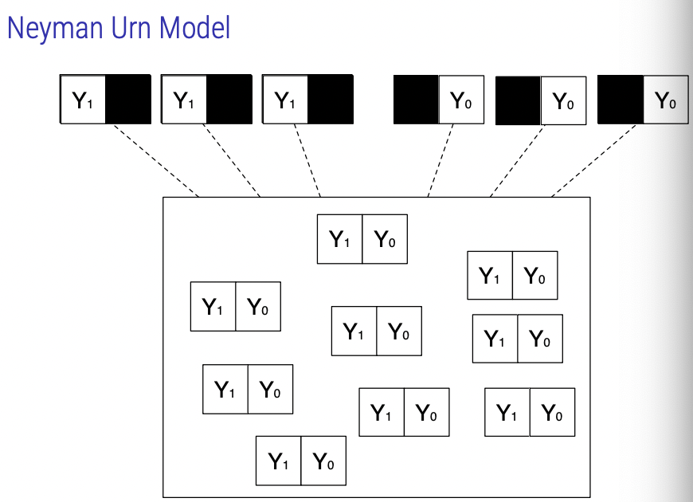

**Stable Unit Treatment Value Assumption (SUTVA)**

Recall: Yi = Y-Di i , or equivalently Yi = Di*Y1i + (1 − Di)*Y0i

My potential outcomes have nothing to do with the treatment assigned to anyone else. In the case of taking a pill, where my outcome is the same if I still just take the pill. As long as my status is the same, everything else is irrelevant.

**SUTVA consists of two sub-assumptions:**

* No interference between units
  + Potential outcomes for a unit not affected by treatment status of other units
  + Violations: spill-over effects, contagion, dilution
* No different versions of treatment (aka stability, consistency)
  + Nominally identical treatments are in fact identical
  + Violations: variable levels of treatment, technical errors

**Causal Inference without SUTVA**

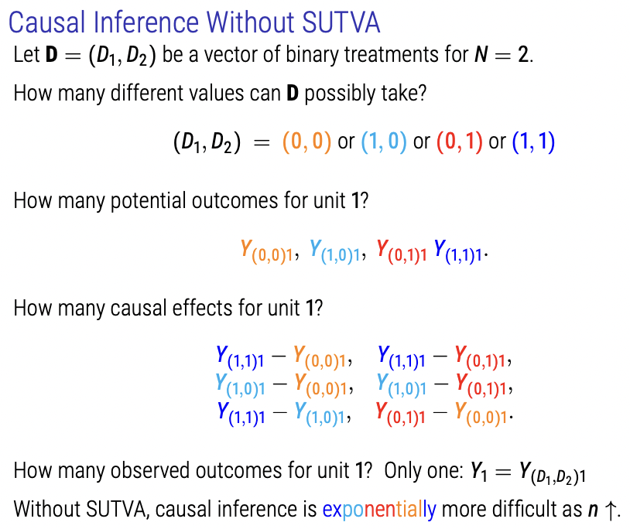

In case of the pill, the reason we have four potential outcomes is because each person’s outcome depends not only on their own treatment status, but also the treatment status of another unit.

**Causal Inference as a Missing Data Problem**

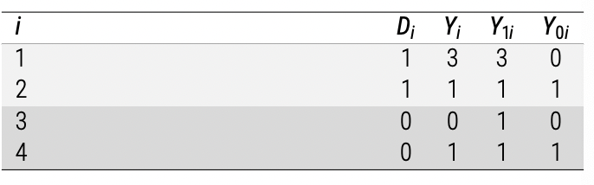

**We take the values of both Y1i and Y0i to be real and fixed for all I, but we can only observe one of them for any I. This is known as the fundamental problem of causal inference (FPCI).**

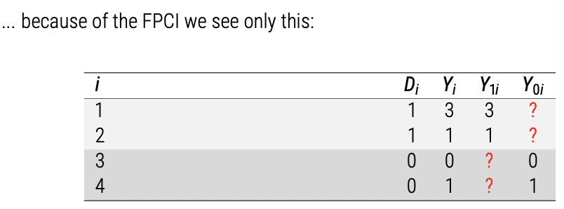

**Our goal:**

* **Define causal estimands in terms of potential outcomes**
* **Estimate them using observable data on this slide**
* **Essentially: fill in the missing counterfactuals as best as possible**

**Estimands**

* The unobserved population parameter or function.

**Estimator**

* A function that can be applied to observed data.

**Estimate**

* A specific output of said function.

To measure how popular Tories are in the U.K:

* Estimand = How popular are the Tories in some population (voters?)
* Estimator = Proportion of people that like the Tories (the mean)
* Estimate = The number generated from the mean

**Unit-level Causal Estimands**

Definition (Individual Treatment Effect)

* Causal effect of the treatment on the outcome for uni I, defined by the comparison of two potential outcomes: Tau-I = Y-1i – Y-0i

**Group-level Causal Estimands**

Values of the potential outcomes for this population can be represented as two vectors:

Y1 = (Y11, Y12, . . . , Y1N)

Y0 = (Y01, Y02, . . . , Y0N)

* A population causal estimand is a **comparison** of Y1 and Y0.

**Average Treatment Effect**

A common choice is a difference of their expected values (means) – named the ATE, or Average Treatment Effect.

Tau-ATE = (Y1i – Y0i)/N or equivalently,

Tau-ATE = E[Y-1i – Y-0i]

**In the rest of this course, we will consider various assumptions under which Tau-ATE can be identified from observed information.**

**Tau-ATE does not exist in realised space, it only exists in Potential Outcome space if potential outcomes are realised.**

Note on notation: We represent the estimand as a greek letter (in this case τ , but could be anything). We typically represent an estimator for that estimand as a greek letter with something on top (e.g. τ˜ or τˆ). An estimate will be a realised number (interval, etc.). Typically a hat!

**Average Treatment Effect on the Treated (ATT)**

* This is the average treatment effect on the treated.
* Above, but conditional by only looking at the treated.

Where does estimand Tau-ATT = Tau-ATE? This is where it is useful.

**Conditional Average Treatment Effect (CATE)**

Same as ATE but conditional on X-I, which is a pre-treatment covariate for unit i. This measures the subgroup effect, treatment effects on units who have particular characteristics x.

* This estimand sometimes goes by other names (local ATE, LATE).
* Used for policy targeting, etc.

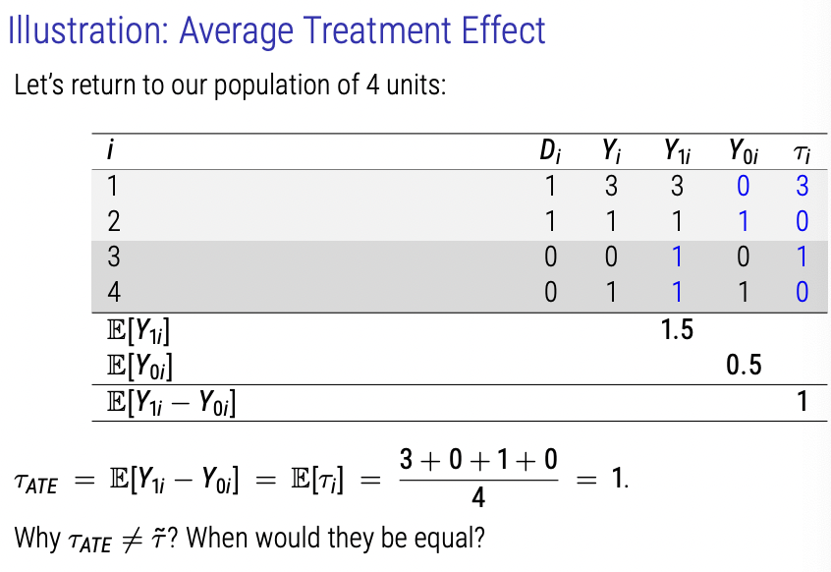

They would be equal under randomization of potential outcomes under control and the same under treatment. The expected value of potential outcoems under treatment are not equal to observed outcomes.

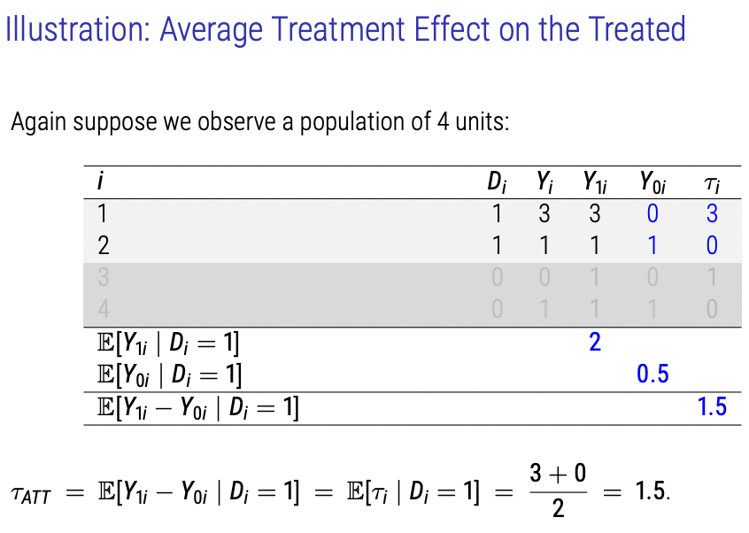

ATT is different from ATE as there is a systematic difference between the two groups.

**Internal and External Validity**

* The term ‘population’ is used here in an unfamiliar-seeming way: It refers only to the N units for whom we have observed data (i.e. what we would typically call the ‘sample’).
* The estimands considered on this course are defined and estimated for this population.
* Internal validity refers to the validity of our estimates of these effects. This class is focused only on internal validity.
* External validity refers to the validity generalising our estimates of causal effects from the ‘population’ of N units to any other population (note, this could include generalising from a realised sample to a population).
* If claimed, external validity had to be justified by different kinds of arguments, e.g.:
  + Representative sampling (ideally probability sampling) of the N units from a larger population. This is a population inference task, as in survey research (see MY456).
  + Substantive theory / assumptions / wishful thinking about why a causal effect for these N units would also apply elsewhere

**Identification Problem for Causal Inference**

* In stats, an estimand (parameter) can be identified if its value can be uniquely estimated based on the observe data.
* Recall that in causal inference, Estimands are population causal effects but the FPCI tells us that at least half of the potential outcomes are always missing.
* An identification strategy is a combination of data and assumptions which allows us to identify a causal estimand by estimating (“fillin in”) the missing potential outcomes (usually at a group level)

**Selection Bias**

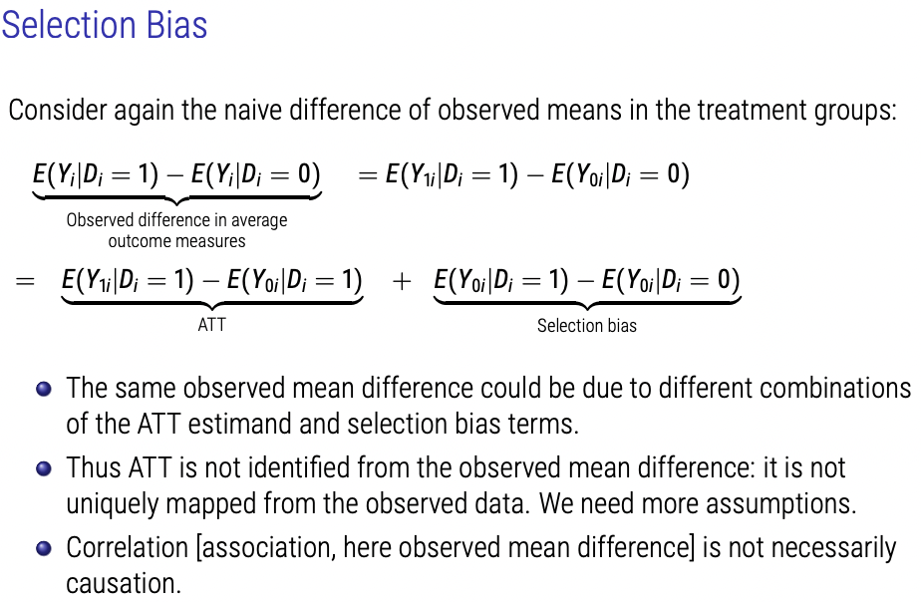

Selection bias is difference between estimator and estimand. We need to come up with an assumption that removes selection bias and says estimator = estimand.

ATT = Average difference in expected value between those who are treated and those in control.

Selection Bias = difference between expected value of potential outcome for the treated under control and the observed value of the untreated under control. This is selection bias because if it is not 0, it implies treatment and control groups are systematically different in potential outcome Y-0i.

* E.g. job training programme
  + Participants are self-selected from a population of individuals in difficult labor situations
  + Perhaps better resourced or more motivated individuals decide to take part
  + Even in the absence of the program, post-training period earnings for those people would then have been higher than those for those who did not opt in.

**Assignment Mechanisms**

Definition: The assignment mechanism is the procedure that determines the treatment status of each unit.

* Most causal inference methods achieve identification by restricting the (assumed) assignment mechanism.
* For example, if we are willing to assume that treatment assignment is independent of potential outcomes under no treatment, then:
  + E(Y0i |Di = 1) − E(Y0i |Di = 0) = 0
* I.e. selection bias is zero and the observed mean difference is (in expectation) equal to ATT (and also ATE in that case).
  + When would this assumption be plausible? Randomisation.

Imbens and Rubin (2015, Ch. 3) present three assumptions about assignment mechanisms (for each unit) that provide the grounds for identification:

1. Individualistic: Assignment does not depend on the covariates or potential outcomes for other units.

2. Probabilistic: There is a nonzero probability of each treatment value, for every unit. 3. Unconfounded: Assignment does not depend on potential outcomes.

Assuming the above, we can distinguish:

Experiments: The assignment mechanism is both known and controlled by the researcher, and

Observational studies: The assignment mechanism is not known to, or not under the control of, the researcher.

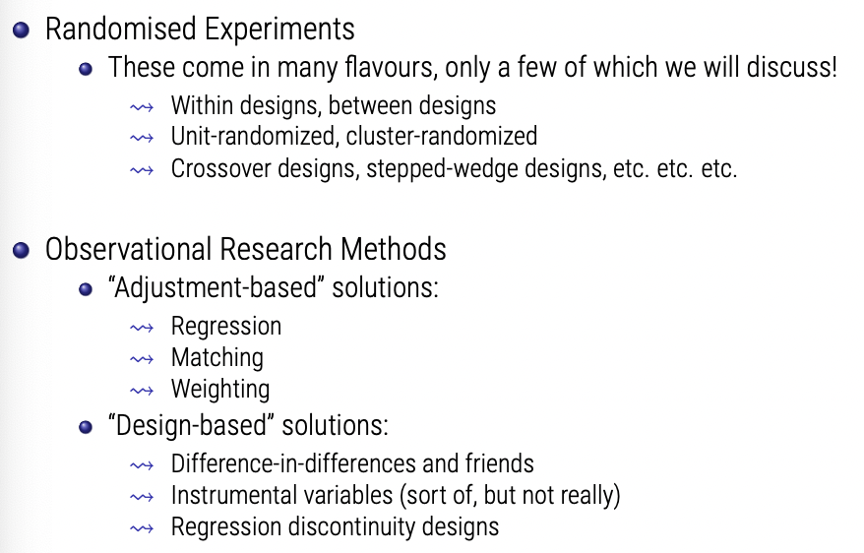

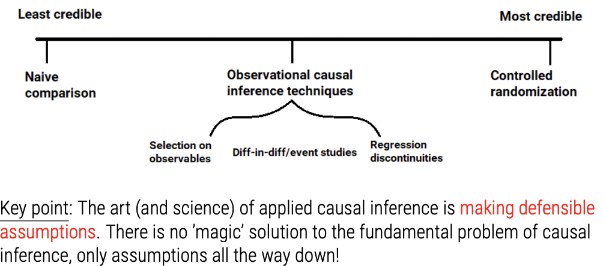

**Dale, A., Strauss, A. “Don’t Forget to Vote: Text Message Reminders as a Mobilization Tool,” *American Journal of Political Science,* 53(4), 787-804, 2009.**

* Testing alternative hypotheses.
* For ITT, we assume that those who change phone numbers (don’t get treatment, even though they are intended to do so by researcher) has no impact on propensity for involvement in politics.

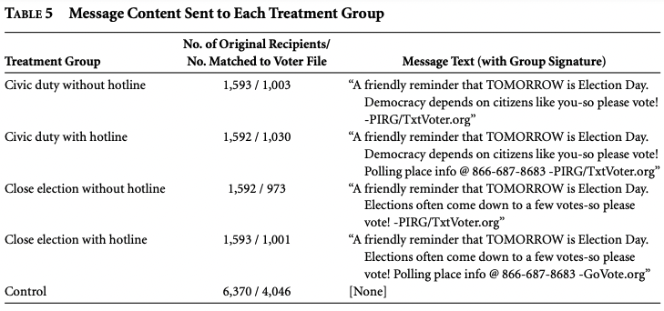

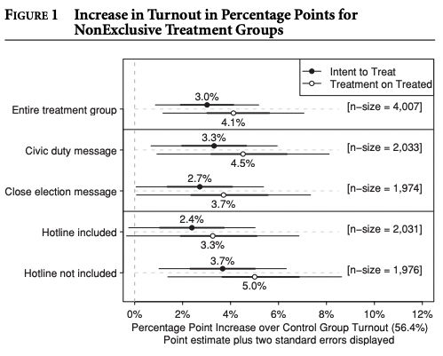

* Talking point on the difference between ATE & ATT In the above cases?
  + What does this imply?

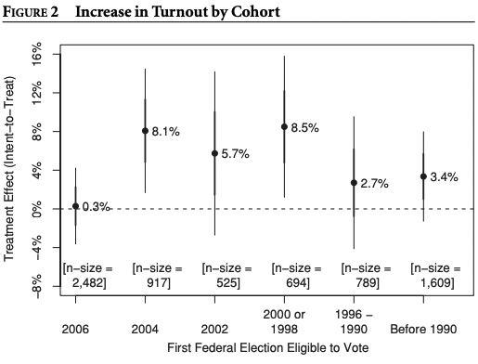

**Reviewer 2 Exercise**

* Why is this study relevant?
  + U.S. Policy, rather than interest in direct democratic process globally
  + Articulate exclusion/inclusion criterion better.
* Registering to vote is a very ‘American’ concept. Doesn’t extend to, for example, European politics as an indicator of interest in voting.
* Political context of registering for party vs. not registering to vote by state.
* Preference for party as covariate could be included.
* Construct validity for messaging differences.
* Socio-economic component associated with phone ownership that affects sampling.

**Holland, P. “Statistics and Causal Inference,” *Journal of the American Statistical Association,* 81(396), 945-960, 1986.**

**What can be a cause? (Tom Robinson)**

It may seem very extreme to some to limit the notion of cause to the sense used in Section 3. Aristotle set the stage for this, however, by distinguishing more than one meaning to the word cause. It might be better to ask, what can be an "efficient cause" in his sense? Evidently even this restriction did not limit the notion of cause for such thinkers as Hume and Mill. Anything can be a cause for them-or, at least, a potential cause. Put as bluntly and as contentiously as possible, in this article I take the position that causes are only those things that could, in principle, be treatments inexperiments. The qualification "in principle" is important because practical, ethical, and other considerations might make some experiments infeasible, that is, limit us to contemplating hypothetical experiments.

ts. For example, in the medical and social world we might be able to conceive of an experiment, but no one would ever try to carry it out. Instead, we might have to wait for a "natural experiment" to occur. "Observational study" is the term used by statisticians (e.g., Cochran 1983) to refer to studies for which "The objective is to study the causal effects of certain agents" but "For one reason or another the investigator can not . .. impose on . . . or withhold from the subject, a treatment whose effects he desires to discover" (p. 1). I believe that the notion of cause that operates in an experiment and in an observational study is the same.

**Lecture 2 – Randomized Experiments**

**(Randomized) Experiments**

* An experiment is a research design where the assignment mechanism is individualistic, probabilistic and unconfounded, and known and controlled by the researchers.
* In a (classical) randomized experiment (‘randomized controlled trial’ or RCT) treatment values are assigned to N units at random, with known and positive assignment probabilities for each treatment to each unit.
* We consider the ‘completely randomized experiment’: a random subset of N1 units assigned to treatment (D = 1) and remaining N0 = N − N1 to control
  + Note D ∈ {0,1}: only treatment and control. Extension to cases with more than two treatment levels is straightforward.
  + Other randomized designs will be introduced at the end of this lecture

Basic problem is that our selection bias term is unknown and thus our ATT is unidentifiable. We need to identify the conditions that make the selection bias term go to 0. We are hoping to prove that the thing we observe in data equals what we’re trying to estimate in society.

Probability of treatment assignment, conditional on potential outcomes, is exactly the same as the probability of being treated – not conditional on outcomes.

* P(D|Y0, Y1) = P(D)

Or said another way:

* (Y1 , Y0) ⊥⊥ D

where ⊥⊥ means “is independent of”

question: does randomization imply Y ⊥⊥ D?

We’re not claiming that treatment is unassociated with outcome. We’re saying that the potential outcomes for those treated and untreated are independent of whether or not they’re treated.

* (Y1 , Y0) ⊥⊥ D means that (in expectation) Y0 is the same for those with D = 1 and for those with D = 0 (and similarly for Y1 )

Under independence from randomized treatment assignment, we have

E[Y0|D = 1] = E[Y0|D = 0] = E[Y0]

thus selection bias equals zero (in expectation). We also have: E[Y1 |D = 1] = E[Y1 |D = 0] = E[Y1 ],

thus: ATT = E[Y1 |D = 1] − E[Y0|D = 1] = E[Y1 ] − E[Y0] = ATE

SO:

**Under complete randomization: E[Y|D = 1] − E[Y|D = 0] = E[Y1 ] − E[Y0] = ATE**

**The observed means difference between the treatment group identifies the causal average treatment effect ATE (as well as ATT and ATU, which both equal to ATE in this case).**

**We can also identify most other population-level causal effects since they are comparisons of some features of the distributions of Y0 and Y1 and we can now estimate both of these distributions.**

**Covariate Balance**

* In expectation, randomization balances all observed and unobserved pre-treatment characteristics between treatment and control groups.
* In any one experimental sample, we might expect some chance imbalance.
* We can check random assignment with respect to observed covariates X using balance tests.
* Exact balance in some X can be ensured with stratified randomization.

**Complications and Limitations**

Randomization (and thus internal validity) can be complicated by:

* missing data (dropout/attrition): outcome is unobserved for some units in a way that is associated with D or potential outcomes.
* non-compliance: some units receive a different treatment than the one they were assigned to.

Randomization does not help with external validity: How well do causal effects for this sample apply to broader population, or other populations?

* Can differentiate Sample ATE (SATE) from Population ATE (PATE) – randomization identifies SATE, but PATE also requires random sampling. Moving to a different population entirely would require other assumptions.

Randomized experiments can be weak in construct validity (Shadish, Cook and Campbell): how well do the versions of treatment and outcome in the experiment match the concept we are actually substantively interested in.

**Estimation and Inference**

Estimation:

* We can use the distributions p(Y|D = 1) and p(Y|D = 0) in the observed data to estimate the distributions of Y1 and Y0 in the population, and thus population causal effects.
* Typically quite simple and familiar methods are sufficient.

Statistical inference:

* Hypothesis tests and confidence intervals tend to be based on the “source of identifying variation” (i.e., what is random?)
* See the discussion in Chapters 5–8 of Imbens & Rubin for more on this, if you are interested.

**Estimating ATE - τATE = E[Y1] − E[Y0]**

An obvious estimator of this is the sample difference-in-means:

τb = ¯Y1 − ¯Y0

where:

Y-hat-1 = Sum(YI*Di)/Sum(Di) = 1/N1 * Sum(Yi) where Di = 1

Y-hat-0 = Sum(YI*(1-Di))/Sum(1-Di) = 1/N0 * Sum(Yi) where Di = 0

with N1 = Sum(i Di) and

N0 = Sum( i (1 − Di)) = N − N1

Have already proven that τb is an unbiased estimator of τATE under randomization!

Estimating ATE with Regression:

The same τATE can also be estimated using a linear regression model

Yi = ˆγ + ˆτDi + ˆεi

(Recall: τˆ from a bivariate regression with a binary independent variable is mathematically equivalent to the difference-in-means.)

It is not necessary to include covariates X in this model because we have an assumption of randomisation and thus X are independent of D.

* But pre-treatment covariates are sometimes included:
  + this can increase precision (reduce standard error) by modeling residual variation in Y
  + can control for observable imbalance (generated by random chance)
  + can allow for estimation of heterogeneous treatment effects by X (by including interactions in the model)
  + but there is a (small) risk of inducing bias, as it changes what you’re trying to estimate to some degree
  + note: do not include post-treatment covariates!

**Two Sample T-Test for Inferencef**

Null hypothesis is that ATE = 0.

T = tau-hat / sqrt(sum(estimated variances of N1 + N2))

We reject the null hypothesis H0: τATE = 0 against the alternative H1 : τATE 6= 0 at the asymptotic 5% significance level if |t| > 1.96. Reject based on dispersion of the data.

**Randomisation Inference**

* For the two-sample t-test, the null hypothesis was that the average treatment effect tau-ATE is 0.
* Consider now instead the sharp null hypothesis (and alternative)
  + This sharp null suggests every individuals treatment effect is 0. All individual causal effects are zero.
    - If we consider this as true, then we observe all the potential outcomes. We can then construct the full population distributions of Y-0i and Y-1i under the sharp null.
  + We can do this because under the sharp null the observed data Yi for every unit would have been exactly the same, no matter the value of Di.

Logic of randomization inference (permutation test, Fisher’s exact test):

1. Permute the values of Di (N1 1s and N0 0s) differently across the N units, keeping Yi unchanged.

2. Calculate and store the value of τ-hat-j (or any other appropriate statistic, such as the t-test statistic) for each of these permuted datasets j.

3. Calculate p-value as the proportion of τ-hat-j that are as or more extreme than the actually observed τ-hat.

* With a larger N, use a random sample of all the permutations.

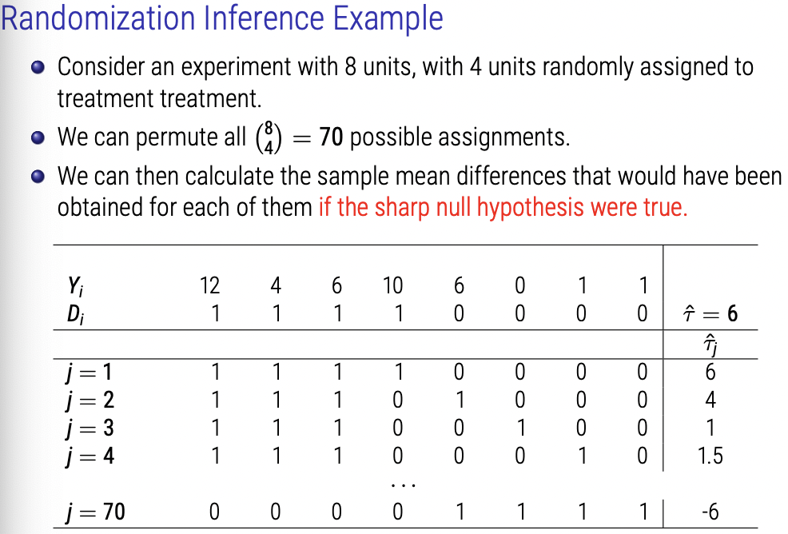

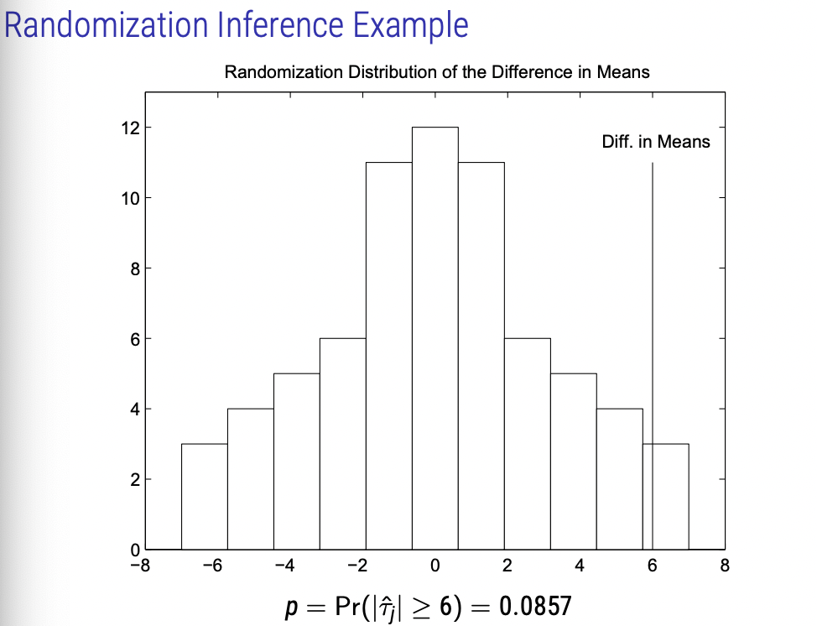

**The Bootstrap**

Another common method for uncertainty estimation is bootstrapping

The basic idea: Simulate the sampling distribution of a statistic via resampling with replacement

Useful when:

* Statistic is so complicated that analytically deriving its sampling variance is too difficult or cumbersome
* Data are so skewed that inference based on asymptotic normality is unlikely to perform well
* Statistic is of a form that makes CLT kick in only slowly, so normal approximation does not work well

Weakness:

* Computationally costly, sometimes prohibitively so
* Not a general solution for small samples (a common misunderstanding!)

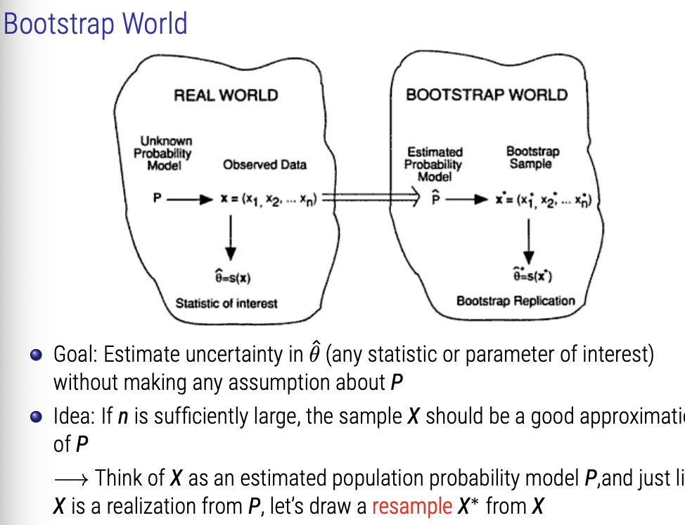

Over literal repeated resamples, we can draw the distribution of our boostrapped samples.

Step-by-Step:

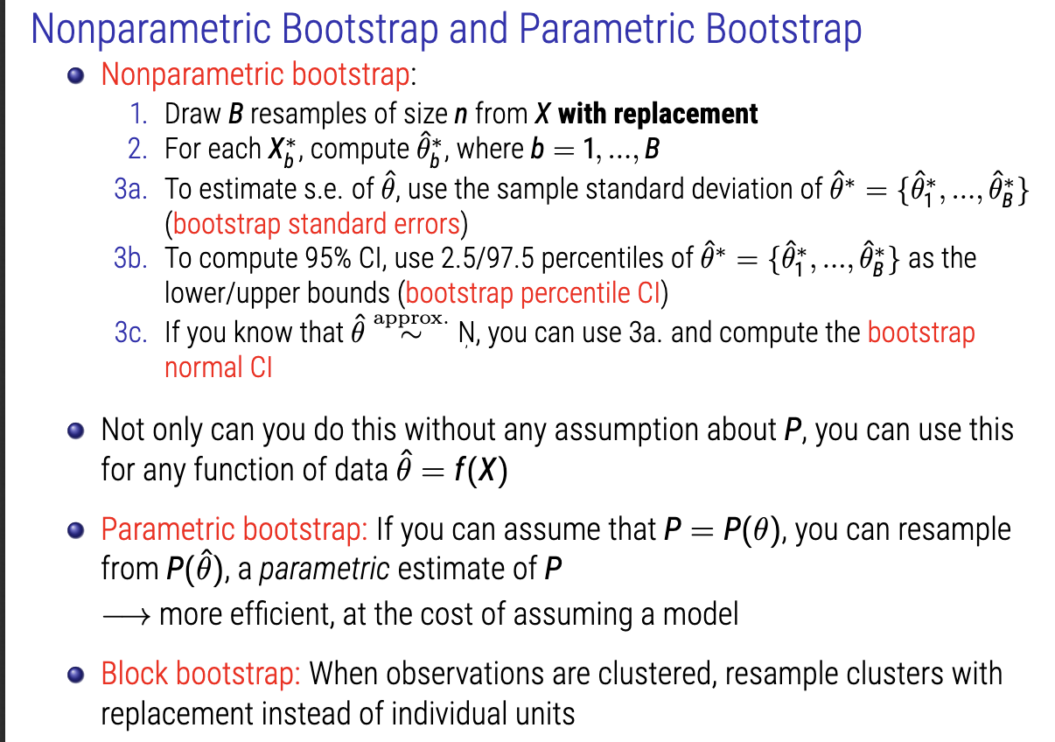

1. Draw X number of resamples of size N, with replacement. (each sample has same number of rows as original sample).
2. Each sample can be drawn as X*b.
3. For each, compute statistic of interest. (difference in means, for example).
4. To estimate s.e. of statistic, use the sampe standard deviation (bootstrap standard errors).
5. Can now calculate the bootstap percentile CI. These are now your confidence intervals.
6. If you know that your estimated statistic is approximately normal, you can use 3a and compute the bootstrap normal CI.

The parametric bootstrap is slightly more controlled and precise, but is a little bit less assumption-free.

* Resample from fit.

Block bootstrap: when observations are clustered, resample clusters with replacemen instead of individual units.

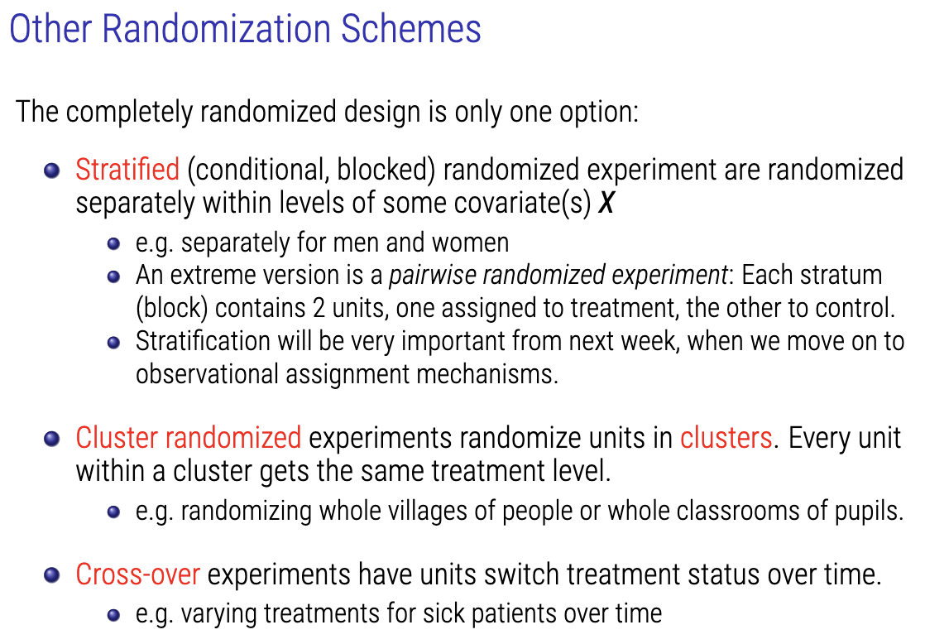

**Imbens, G. W. and Rubin, D. B. (2015).**[**Causal Inference for Statistics, Social, and Biomedical Sciences: An Introduction**](https://www-cambridge-org.gate3.library.lse.ac.uk/core/books/causal-inference-for-statistics-social-and-biomedical-sciences/71126BE90C58F1A431FE9B2DD07938AB)**. Cambridge University Press.**

**Ch.1**

Although the definition of causal effects does not require more than one unit, learning about causal effects typically requires multiple units. Because with a single unit we can at most observe a single potential outcome, we must rely on multiple units to make causal inferences. More specifically, we must observe multiple units, some exposed to the active treatment, some exposed to the alternative (control) treatment.

In many situations it may be reasonable to assume that treatments applied to one unit do not affect the outcome for another unit. For example, if we are in different locations and have no contact with each other, it would appear reasonable to assume that whether you take an aspirin has no effect on the status of my headache. (But, as the example in the previous section illustrates, this assumption need not hold if we are in the same location, and your behavior, itself affected by whether you take an aspirin, may affect the status of my headache, or if we communicate by extrasensory perception.) The stable unit treatment value assumption, or SUTVA (Rubin, 1980a) incorporates both this idea that units do not interfere with one another and the concept that for each unit there is only a single version of each treatment level (ruling out, in this case, that a particular individual could take aspirin tablets of varying efficacy):

Assumption 1.1 (SUTVA) *The potential outcomes for any unit do not vary with the treatments assigned to other units, and, for each unit, there are no different forms or versions of each treatment level, which lead to different potential outcomes.*

These two elements of the stability assumption enable us to exploit the presence of multiple units for estimating causal effects. SUTVA is the first of a number of assumptions discussed in this book that are referred to generally as exclusion restrictions: assumptions that rely on external, substantive, information to rule out the existence of a causal effect of a particular treatment relative to an alternative.

If we are willing to accept SUTVA, our complicated “You” and “I” aspirin example simplifies to the situation depicted in Table 1.3. Now You and I each face only two treatment levels (e.g., for “You” whether or not “You” take an aspirin), and the accompanying potential outcomes are a function of only our individual actions. This extends readily to many units.

Suppose, in the two-person headache example, that the person who chose not to take the aspirin did so because he had only a minor headache. Suppose then that an hour later both headaches have faded: the headache for the first person possibly faded because of the aspirin (it would still be there without the aspirin), and the headache of the second person faded simply because it was not a serious headache (it would be gone even without the aspirin). When comparing these two observed potential outcomes, we might conclude that the aspirin had no effect, whereas in fact it may have been the cause of easing the more serious headache. The key piece of information that we lack is how each individual came to receive the treatment level actually received: in our language of causation, the assignment mechanism.

Because causal effects are defined by comparing potential outcomes (only one of which can ever be observed), they are well defined irrespective of the actions actually taken. But, because we observe at most half of all potential outcomes, and none of the unit-level causal effects, there is an inferential problem associated with assessing causal effects. In this sense, the problem of causal inference is, as pointed out in Rubin (1974), a missing data problem: given any treatment assigned to an individual unit, the potential outcome associated with any alternate treatment is missing. A key role is therefore played by the missing data mechanism, or, as we refer to it in the causal inference context, the assignment mechanism. How is it determined which units get which treatments or, equivalently, which potential outcomes are realized and which are not? This mechanism is, in fact, so crucial to the problem of causal inference that Parts II through VI of this book are organized by varying assumptions concerning this mechanism.

To illustrate the clarity that comes with the potential outcomes interpretation of causality, we consider a problem from the literature that is known as Lord’s paradox:

*A large university is interested in investigating the effects on the students of the diet provided in the university dining halls and any sex differences in these effects. Various types of data are gathered. In particular, the weight of each student at the time of his arrival in September and his weight the following June are recorded. (Lord, 1967, p. 304)*

**Assignment Mechanisms (Ch. 3)**

**3 conditions must be satisfied:**

1. **Individualistic Assignment**
   1. Limits the dependence of the treatment assignment for unit I on the outcomes and assignments for other units.
      1. Violated in sequential experiments.
2. **Probabilistic Assignment**
   1. Every unit has positive probability of being assignment to treatment level 0 and treatment level 1.
      1. Note that this merely requires that every unit has the possibility of being assigned to the active treatment and the possibility of being assigned to the control treatment.
3. **Unconfounded Assignment**
   1. Restriction on the dependence of the assignment mechanisms on potential outcomes
      1. Does not depend on potential outcomes.
      2. If an assignment mechanism is unconfounded, we can drop the two potential outcomes as arguments and write the assignment mechanism as Pr(W|X).
   2. Note that, under unconfoundedness, the propensity score is no longer just the average assignment probability for units with covariate value Xi = x; it can also be interpreted as the unit level assignment probability for such units.
4. **Given individualistic assignment, the combination of probabilistic and unconfounded assignment is referred to as strongly ignorable treatment assignment (Rosenbaum and Rubin, 1983a). More generally, ignorable treatment assignment refers to the weaker restriction where the assignment mechanism can be written in terms of W, X, and Yobs only, without dependence on Ymis (Rubin, 1978).**

The propensity score at x is the population average unit assignment probability for units with Xi = x, for all x in the support of Xi; e(x) is here a function of φ and θ, a dependence that we usually suppress in notation.

**Randomized Experiment:**

A randomized experiment is an assignment mechanism that:

* (i) is probabilistic, and
* (ii) has a known functional form that is controlled by the researcher.

**Classical Randomized Experiment**

A classical randomized experiment is a randomized experiment with an assignment mechanism that is:

* (i) individualistic, and
* (ii) unconfounded.

The definition of a classical randomized experiment rules out sequential experiments as in Example 4. In sequential experiments, the assignment for units assigned in a later stage of the experiment generally depends on observed outcomes for units assigned earlier in the experiment. A leading case of a classical randomized experiment is a completely randomized experiment, where, a priori, the number of treated units, Nt, is fixed (and thus the number of control units Nc = N −Nt is fixed as well). In such a design, Nt units are randomly selected, from a population of N units, to receive the active treatment, with the remaining Nc assigned to the control group.

**Observational Study**

An assignment mechanism corresponds to an observational study if the functional form of the assignment mechanism is unknown.

We assume that assignment to treatment itself is unconfounded but allow receipt of treatment to be confounded. This class of assignment mechanisms includes noncompliance in randomized experiments and sometimes utilizes instrumental variables analyses. Often in these designs, the receipt of treatment can be viewed as “latently regular” – that is, it would be regular given some additional covariates that are not fully observed. To conduct inference in such settings, it is often useful to invoke additional conditions, in particular exclusion restrictions, which rule out the presence of particular causal effects.

**Regular Assignment Mechanism**

An assignment mechanism is regular if:

* (i) the assignment mechanism is individualistic,
* (ii) the assignment mechanism is probabilistic, and
* (iii) the assignment mechanism is unconfounded.

If, in addition, the functional form of a regular assignment mechanism is known, the assignment mechanism corresponds to a classical randomized experiment. If the functional form is not known, the assignment mechanism corresponds to an observational study with a regular assignment mechanism.

**Classical Randomized Experiments (Ch. 4)**

The four examples, Bernoulli trials, completely randomized experiments, stratified randomized experiments (randomized blocks), and paired randomized experiments, all satisfy the four criteria necessary for assignment mechanisms to be classified as classical randomized experiments. So, they are all:

* Individualistic,
* Probabilistic,
* Unconfounded,
* Known functional form.

The key difference between the four types of classical randomized experiments we consider in this chapter is in the set of assignment vectors W (the N-dimensional vector with elements Wi ∈ {0, 1}) with positive probability.

**BERNOULLI TRIALS**

A Bernoulli trial is a classical randomized experiment with an assignment mechanism such that the assignments for all units are independent.

The simplest Bernoulli experiment tosses a fair coin for each unit: if the coin is heads, the unit is assigned the active treatment, and if it is tails, the unit is assigned the control treatment. Because the coin is fair, the unit-level probabilities and the propensity scores are all 0.5. Because the tosses are independent, the probability of any W for the N units in the study is the product of the individual probabilities.

Our final generalization of Bernoulli trials allows the unit probabilities to vary with the unit’s covariate values. This situation can occur, for example, when certain types of patients are thought to do better on one treatment than another, and the strength of this belief about the better treatment varies with characteristics of the person (e.g., age, sex, race). Here, each unit has a special coin tossed, with the probability that the coin comes up heads equal to the probability that the unit is treated: the unit’s propensity score.

**COMPLETELY RANDOMIZED EXPERIMENTS**

In the second design we consider, the completely randomized experiment, a fixed number of subjects is assigned to receive the active treatment. The simplest completely randomized experiment takes an even number of units and divides them at random in two groups, with exactly one-half of the sample receiving the active treatment and the remaining units receiving the control treatment.

Although often very sensible, completely randomized experiments are not without drawbacks, especially when important covariates are available. Important covariates here means covariates a priori thought to be possibly highly associated with the potential outcomes. Consider, for example, a study with N = 20 units, ten men and ten women, where the potential treatment and control outcomes are a priori thought to vary substantially by sex. Then, although a completely randomized design with Nt = 10 would ensure that ten units get treated, there is the possibility that all ten of them are men (or women). In that case, average differences in the potential outcomes for active and control treatments could be due to sex differences rather than treatment effects. Related complications with relatively unhelpful (in the sense of being uninformative) experiments occur when only a single man is treated and nine men are in the control group, and so forth.

**STRATIFIED RANDOMIZED EXPERIMENTS**

With the stratified randomized experiment, the population of units in the study is first partitioned into blocks or strata so that the units within each block are similar with respect to some (functions of) covariates thought to be predictive of potential outcomes. Then, within each block, we conduct a completely randomized experiment, with assignments independent across blocks.

The simplest randomized block experiment involves two blocks, say males and females, where independent completely randomized experiments are conducted for each group. There is no requirement that the numbers of males and females are the same.

In this setting, the unit-level assignment probability or, equivalently in our situation with a classical randomized experiment, the propensity score, e(Xi), is equal to Nt(j)/N(j) for all units with Bi = j. As this representation makes explicit, this probability can vary with the stratum indicator. Often, however, the unit-level assignment probabilities are identical across the strata so that e(x) = q for all x. In this case, the only difference between the stratified and completely randomized experiment is that in the former the relative sample size for treatment and control groups is constant across strata, whereas in the latter it may vary.

If the covariates defining Bi correspond to substantive information about the units, in the sense that Bi is predictive of the potential outcomes, (Yi(0), Yi(1)), randomizing within the strata will lead to more precise inferences by eliminating the possibility that all or most units of a certain type, as defined by the blocks, are assigned to the same level of the treatment. Furthermore, even if there is no predictive power of the blocking indicator Bi, stratification does not reduce actual precision, though it reduces the number of allowable values of the assignment vector.

**PAIRED RANDOMIZED EXPERIMENTS**

The paired comparison, or randomized paired design, is an extreme version of the randomized block experiment in which there are exactly two units within each block, and a fair coin is tossed to decide which member of the pair gets the active treatment and which gets the control treatment. As an example, consider an educational experiment with a covariate, a pre-test score, and the students are ranked from high to low on their scores on this pre-test. The top two form the first pair, the next two form the next pair, and so forth. Within each pair, one of the two units is randomly assigned to the treatment, with the probability of assignment equal to 1/2.

**Operational Differences**

First, consider a Bernoulli trial. In this case, there are 2N different values for the assignment vector. The first row in Table 4.1 shows that with N = 4 units, this corresponds to 16 assignment vectors. With N = 16, the number of possible treatment assignment combinations increases to more than 65,000. Next consider a completely randomized experiment with Nt = N/2 units assigned to treatment and Nc = N/2 assigned to control. The number of allowed values for the assignment vector is now N N/2 , which is strictly less than the 2N values allowed under the Bernoulli design. With N = 4 units, we now have only six possible assignment vectors; with a sample of N = 16, we have 12,870 possible assignment vectors, or roughly one-fifth the number possible with the Bernoulli trial.

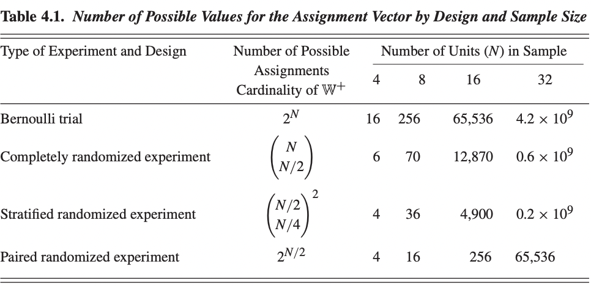

**Chapter 5: Fisher’s Exact P-Values for Completely Randomized Experiments**

Given data from a completely randomized experiment, Fisher was intent on assessing the sharp null hypothesis (or exact null hypothesis, Fisher, 1935) of no effect of the active versus control treatment, that is, the null hypothesis under which, for each unit in the experiment, both values of the potential outcomes are identical. In this setting, Fisher developed methods for calculating “p-values.”

We refer to them as Fisher Exact P-values (FEPs), although we use them more generally than Fisher originally proposed. Note that Fisher’s null hypothesis of no effect of the treatment versus control whatsoever is distinct from the possibly more practical question of whether the typical (e.g., average) treatment effect across all units is zero. The latter is a weaker hypothesis, because the average treatment effect may be zero even when for some units the treatment effect is positive, as long as for some others the effect is negative.

Under Fisher’s null hypothesis, and under sharp null hypotheses more generally, for units with either potential outcome observed, the other potential outcome is known; and so, under such a sharp null hypothesis, both potential outcomes are “known” for each unit in the sample – being either directly observed or inferred through the sharp null hypothesis.

Consider any test statistic T: a function of the stochastic assignment vector, W; the observed outcomes, Yobs; and any pre-treatment variables, X. As we discuss in more detail shortly, the fact that the null hypothesis is sharp allows us to determine the distribution of T, generated by the complete randomization of units across treatments.

The test statistic is stochastic solely through the stochastic nature of the assignment vector. We refer to the distribution of the statistic determined by the randomization as the randomization distribution of the test statistic T. Using this distribution, we can compare the actually observed value of the test statistic, Tobs, against the distribution of T under the null hypothesis. An observed value that is “very unlikely,” given the null hypothesis and the induced distribution for the test statistic, will be taken as evidence against the null hypothesis in what is, essentially, a stochastic version of the mathematician’s “proof by contradiction.” How unusual the observed value is under the null hypothesis will be measured by the probability that a value as extreme or more extreme (in practice, as large or larger) would have been observed – the significance level or p-value.

Hence, the FEP approach entails two steps: (i) the choice of a sharp null hypothesis (in Fisher’s original version, always the null hypothesis of no effect whatsoever, but easily generalized to any sharp null hypothesis, that is, a null hypothesis that allows us to infer all the missing potential outcomes from the observed potential outcomes), and (ii) the choice of test statistic. The scientific nature of the problem should govern these choices.

An important characteristic of this approach is that it is truly nonparametric, in the sense that it does not rely on a model specified in terms of a set of unknown parameters. In particular, we do not model the distribution of the outcomes: the vectors of potential outcomes Y(0) and Y(1) are regarded as fixed but a priori unknown quantities. The only reason that the observed outcomes, Yobs, and thus the statistic, Tobs, are random is that a stochastic assignment mechanism determines which of the two potential outcomes we observe for each unit. This assignment mechanism is, by definition, known for a classical randomized experiment. In addition, given the null hypothesis, all potential outcomes are known. Thus, we do not need modeling assumptions to calculate the randomization distribution of any test statistic; instead, the assignment mechanism completely determines the randomization distribution of the test statistic. The validity of any resulting p-value is therefore not dependent on assumptions concerning the distribution of the potential outcomes.

This freedom from reliance on modeling assumptions does not mean, of course, that the values of the potential outcomes do not affect the properties of the test. These values will certainly affect the distribution of the p-value when the null hypothesis is false (i.e., the statistical power of the test). They will not, however, affect the validity of the test, which depends solely on the randomized assignment mechanism.

**Calculation**

Under this null hypothesis, for each child, the missing potential outcomes, Ymis i are identical to the observed outcomes for the same child, Yobs i , or Ymis i = Yobs i for all i = 1, ... , N. Thus, we can fill in all six of the missing entries in Table 5.3 using the observed data; Table 5.4 lists the fully expanded data set under Fisher’s sharp null hypothesis. This step is the first key insight of the FEP approach; under the sharp null hypothesis, all the missing values can be inferred from the observed ones.

**From:** 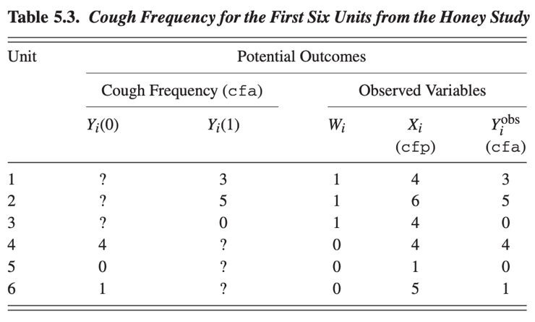

**To:** 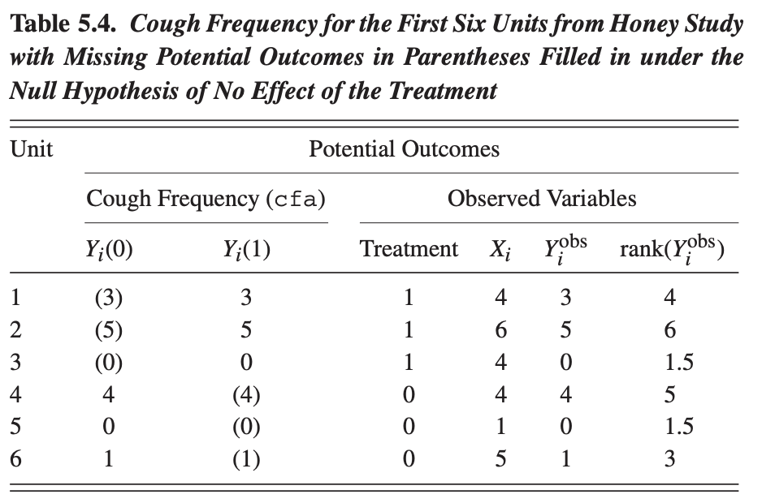

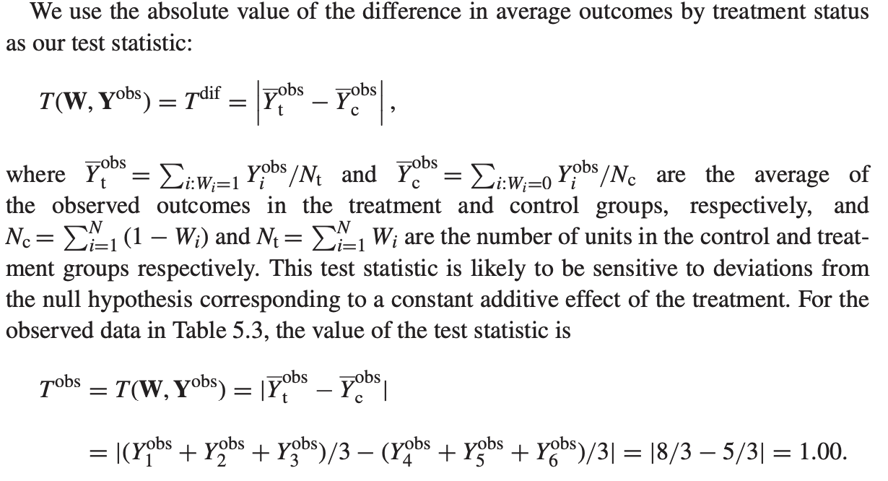

Calculating null hypothesis for exact test

Now, which units get the treatment will affect the null hypothesis test statistic due to different values. Hence, we can repeat this calculation for each possible assignment vector, as seen below: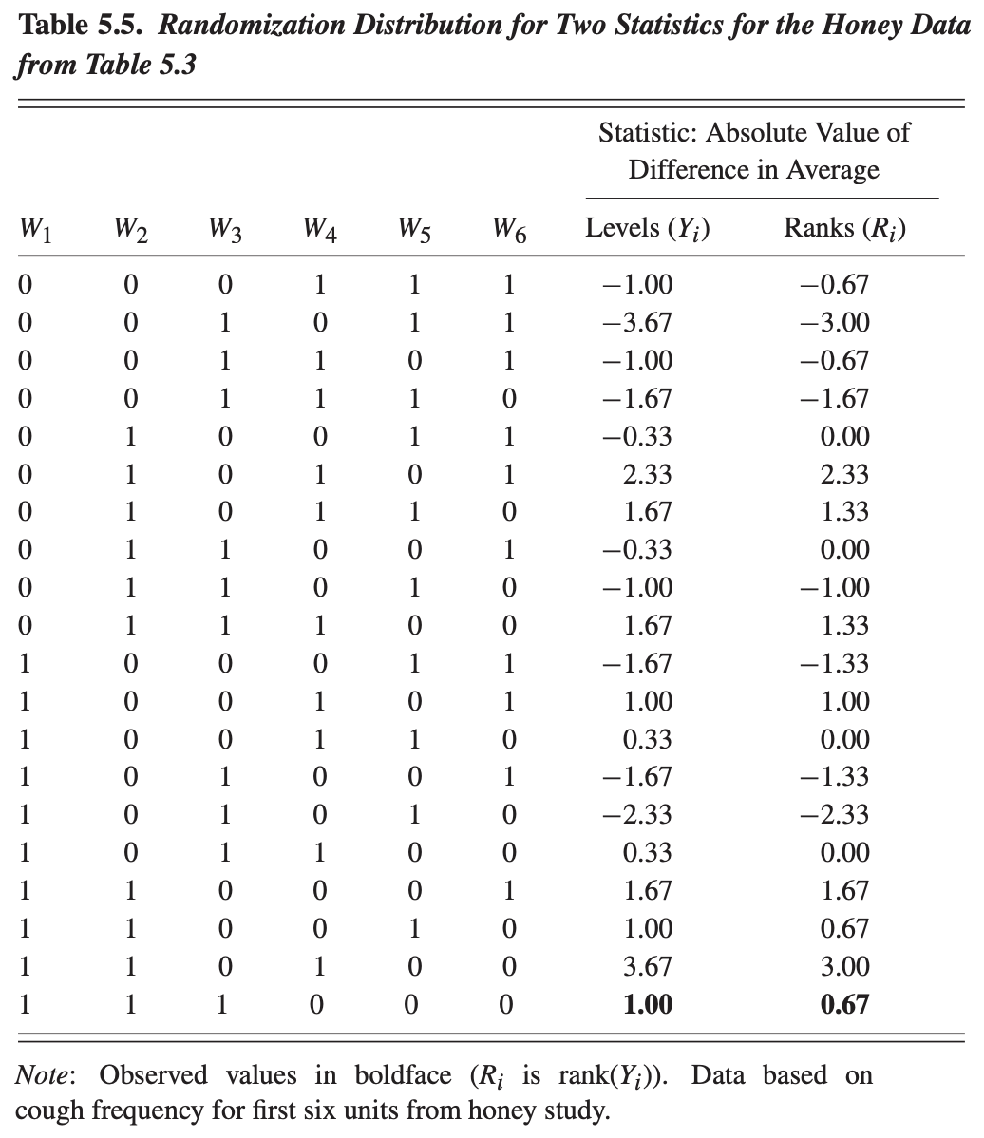

Thus, the value of the corresponding T(W, Y-obs) varies with W. For each vector of assignments, we calculate the corresponding value of the statistic. In this case, T-obs = 1 means that the measure of the average cough frequency who had been given treatment differs by 1 unit of keasurement from the avg of the 3 who were in control. The other rows list the value of the statistic under the alternative values of the assignment vector for the expanded data of Table 5.4. Under random assignment, each assignment vector has prior probability 1/20. Thus we can derive the prior probabilities for each of the twenty values of the test statistic under Fisher’s null hypothesis.

Given the distribution of the test statistic, we can ask the following question: How unusual or extreme is the observed absolute average difference between children who had been given honey versus nothing (the number 1.00) assuming the null hypothesis is true? That is, how unusual is this observed difference, assuming that there is, in fact, absolutely no causal effect of giving honey on cough frequency?

One way to implement this calculation is to ask how likely it is, according to the randomization distribution, to observe a value of the test statistic that is as large as the one actually observed, or even larger. This calculation clearly underestimates the likelihood of the observed result because it bundles it with all rarer events. Simply counting from Table 5.5 we see that there are sixteen assignment vectors with at least a difference in absolute value of 1.00 between children in the treated and control groups, out of a set of twenty possible assignment vectors. This corresponds to a p-value **of 16/20 = 0. 80** for the given combination of the sharp null hypothesis and the test statistic.

Under the null hypothesis of absolutely no effect of administering honey, the observed difference could, therefore, well be due to chance. If there were no effect of giving honey at all, we could have seen an effect as large as, or larger than, the one we actually observed for eighty out of every hundred times that we randomly assigned the honey. Note that, with three children out of six receiving the treatment, the most extreme p-value that we could have for this statistic for any values of the data is 2/20 = 0. 10; if T = t is a possible value for the test statistic, then t will also be the value of the test statistic obtained by using the opposite assignment vector. Hence the sample of size six is generally too small to be able to assess, with any reasonable certainty, the existence of some effect of honey versus nothing – the sample size is not sufficient to have adequate statistical power to reach any firm conclusion.

The first choice that arises when calculating the FEP is the choice of null hypothesis. Fisher himself only focused on what is arguably the most obvious sharp null hypothesis, that of no effect whatsoever of the active treatment:

H0 : Yi(0) = Yi(1), for i = 1, ... , N. (5.1)

We need not necessarily believe such a null hypothesis, but we may wish to see how strongly the data can speak against it. Note again that this sharp null hypothesis of no effect whatsoever is very different from the null hypothesis that the *average effect* of the treatment in the sample of N units is zero. This “average null” hypothesis is not a sharp null hypothesis, because it does not allow the researcher to infer values for all potential outcomes in the sample. The “average null” therefore does not fit into the framework that originates with Fisher, or its direct extensions. This does not imply that the average null hypothesis is less relevant than the hypothesis that the treatment effect is zero for all units.

Definition 5.1 (Statistic) A statistic **T** is a known, real-valued function **T(W, Yobs, X)** of: the vector of assignments, **W;** the vector of observed outcomes, **Yobs** (itself a function of **W** and the potential outcomes **Y(0)** and **Y(1));** and the matrix of pre-treatment variables, **X.**

**Testing hypothesis with error terms built in**

Earlier we discussed how we can use FEP calculations for null hypotheses other than that of absolutely no effect of the treatment, even if this was never considered in the original proposals by Fisher. Suppose, for example, we wish to assess the null hypothesis that for all units the effect of the treatment is an increase in test score equal to C = 0.5: Yi(1) = Yi(0) + 0.5. This assumption is itself a sharp null hypothesis and allows us to fill in all of the missing outcomes; Table 5.6 lists the full set of potential outcomes for the first six observations in the honey data set based on this null hypothesis. Given this complete knowledge, we can again calculate the randomization distribution of any test statistic and the corresponding p-value of any observed test statistic. Let us now do this for a range of values of a postulated effect τ . The second column of Table 5.7 lists, for the full honey data set, the FEPs associated with a constant treatment effect, C, for C ∈ {−3, −2.75, −2.50, ... , 1. 00}. Here the test statistic is the absolute value of the difference in average outcomes for treated and control units minus C, and the p-value is the proportion of draws of the assignment vector leading to a test statistic at least as large as the observed value of that test statistic.

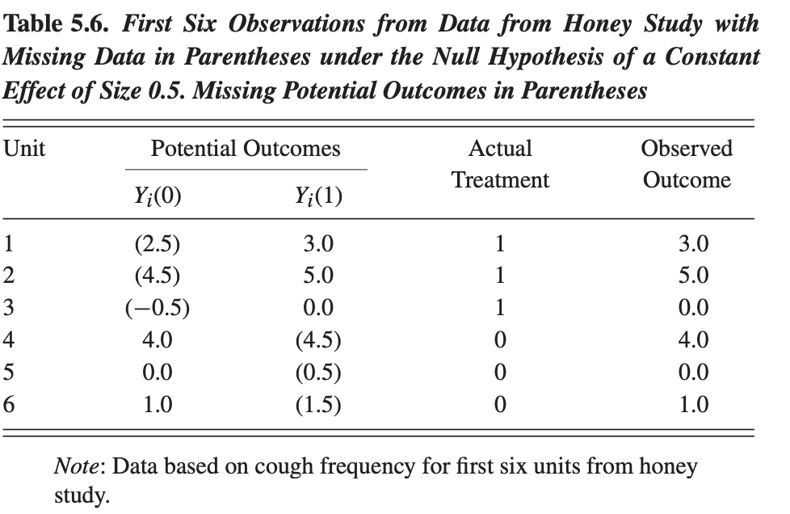

**Approximating P-values when sample size is big (and you cant manually compute each potential iteration of randomisation)**

It is typically very easy to obtain an accurate approximation of the p-value associated with a specific test statistic and null hypothesis. To do this, instead of calculating the statistic for every single value of the assignment vector W ∈ W+, we calculate it for only a randomly chosen subset of possible assignment vectors. 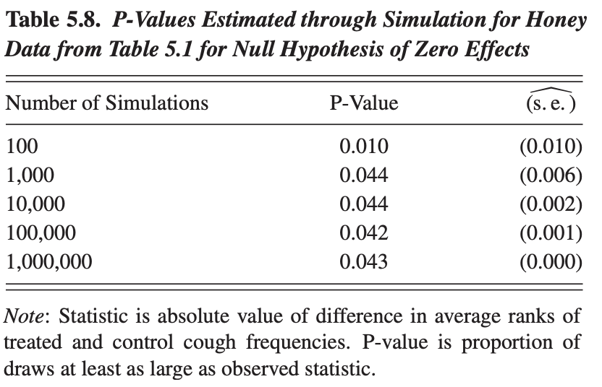

In practice, if K is large, the p-value based on a random sample will be quite accurate. For this approximation, it does not matter whether we sample with or without replacement. The latter will lead to slightly more precise p-values for modest values of K, but both will lead to accurate p-values with K large enough because each assignment vector has the same probability of being drawn with or without replacement. The accuracy of this approximation is, therefore, entirely within the researcher’s control. One can determine the number of independent draws required for a given degree of accuracy. Given a true p-value of p∗, and K draws from the set of possible assignment vectors, the large-sample standard error of the p-value is √p∗(1 − p∗)/K. The maximum value for the standard error is achieved at p∗ = 1/2, in which case the standard error of the estimated p-value is 1/(2√K). Hence, if we want to estimate the p-value accurately enough that its standard error is less than 0.001, it suffices to use K = 250, 000 draws, which is computationally entirely feasible unless the calculation of the test statistic is itself tedious (which it rarely is, although it can be, for example, when the test statistic is based on a model without closed-form estimates).

**Fisher Exact P-Values with Covariates**

Thus far, all of the statistics considered have ignored the presence of any pre-treatment variables. Their presence greatly expands the set of possible test statistics. Here we discuss a few additional statistics that are feasible exploiting the presence of covariates. First, one can use the pre-treatment variables to transform the observed outcome. For instance, if the pre-treatment variable is analogous to the outcome but measured prior to assignment to treatment or control (for instance, a pre-test score), it can be useful to subtract this variable from the potential outcomes and then carry out the test on the transformed outcomes, commonly referred to as gain scores. Thus, define:

Y i(w) = Yi(w) − Xi, for each level of the treatment w, and define the realized transformed outcome as: (see page 78)

Y,obs-i = Yobs-i − Xi = BIG BRACKET( Y i(0) if Wi = 0, Y i(1) if Wi = 1.

The FEP approach is an excellent one for simple situations when one is willing to assess the premise of a sharp null hypothesis. It is also a very useful starting point, prior to any more sophisticated analysis, to investigate whether a treatment does indeed have some effect on outcomes of interest. For this purpose, an attractive approach is to use the test statistic equal to the absolute value of the difference in average ranks by treatment status, and to calculate the p-value as the probability, under the null hypothesis of absolutely no effect of the treatment, of the test statistic being as large as, or larger than, the realized value of the test statistic. In most situations, however, researchers are not solely interested in obtaining p-values for sharp null hypotheses. Simply being confident that there is some effect of the treatment for some units is not sufficient to inform policy decisions. Instead researchers often wish to obtain estimates of the average treatment effect without being concerned about variation in the effects. In such settings the FEP approach does not immediately apply. In the next chapter, we discuss a framework for inference developed by Neyman (1923) that does directly apply in such settings, at least asymptotically, while maintaining a randomization perspective.

**Cinelli, C., Forney, A., Pearl, J. “A Crash Course in Good and Bad Controls,” *Journal Sociological methods and Research.***

For this crash course, it is important to recall the three main sources of association that form the building blocks of a DAG, and when these are closed or opened:

1. *Mediators*, or chains, are patterns of the form X → Z → Y , meaning that X causally affects Y through the mediator Z. Conditioning on Z in a chain blocks (closes) this flow of association.
2. *Common causes,* or forks, are patterns of the form X ← Z → Y , meaning X and Y share a common cause (a confounder) Z, thus inducing a non-causal association between both variables. Conditioning on Z in a fork blocks this flow of association.
3. *Common effects*, or colliders, are patterns of the form X → Z ← Y , meaning that both X and Y share a common effect Z. Contrary to the other two variables, by default a common effect does not induce an association between X and Y . However, conditioning on Z induces a non-causal association between both variables.

Moreover, one important fact to keep in mind is that controlling for a descendant of a variable is equivalent to “partially” controlling for that variable. Any arbitrary path p from X to Y (consisting of a sequence of mediators, common causes, or colliders) will be blocked conditional on Z if, and only if, Z is a common cause or mediator along the path, or if p contains a collider and Z is not that collider, nor any of its descendants. We say that Z d-separates X from Y if Z blocks (closes) all paths from X to Y ; d-separation implies that Y and X are conditionally independent given Z.

Note that causal paths from X to Y are paths of the form X → · · · → Y , namely, those consisting of a sequence of (possibly empty) mediators. All other paths are noncausal and may induce “spurious” associations between X and Y . In particular, for a 3 given variable X, we call “back-door” paths those confounding paths that begin with an arrow pointing into X. If we are interested, then, in estimating the causal effect of X on Y , our task is conceptually simple: we must block all spurious paths between X and Y , and we must not perturb any of the causal paths between them. This will be our guiding principle for deciding whether or not Z should be included in the regression equation, and it characterizes the essence of the graphical conditions known as the back-door criterion and the adjustment criterion (Pearl, 1995; Shpitser et al., 2012).

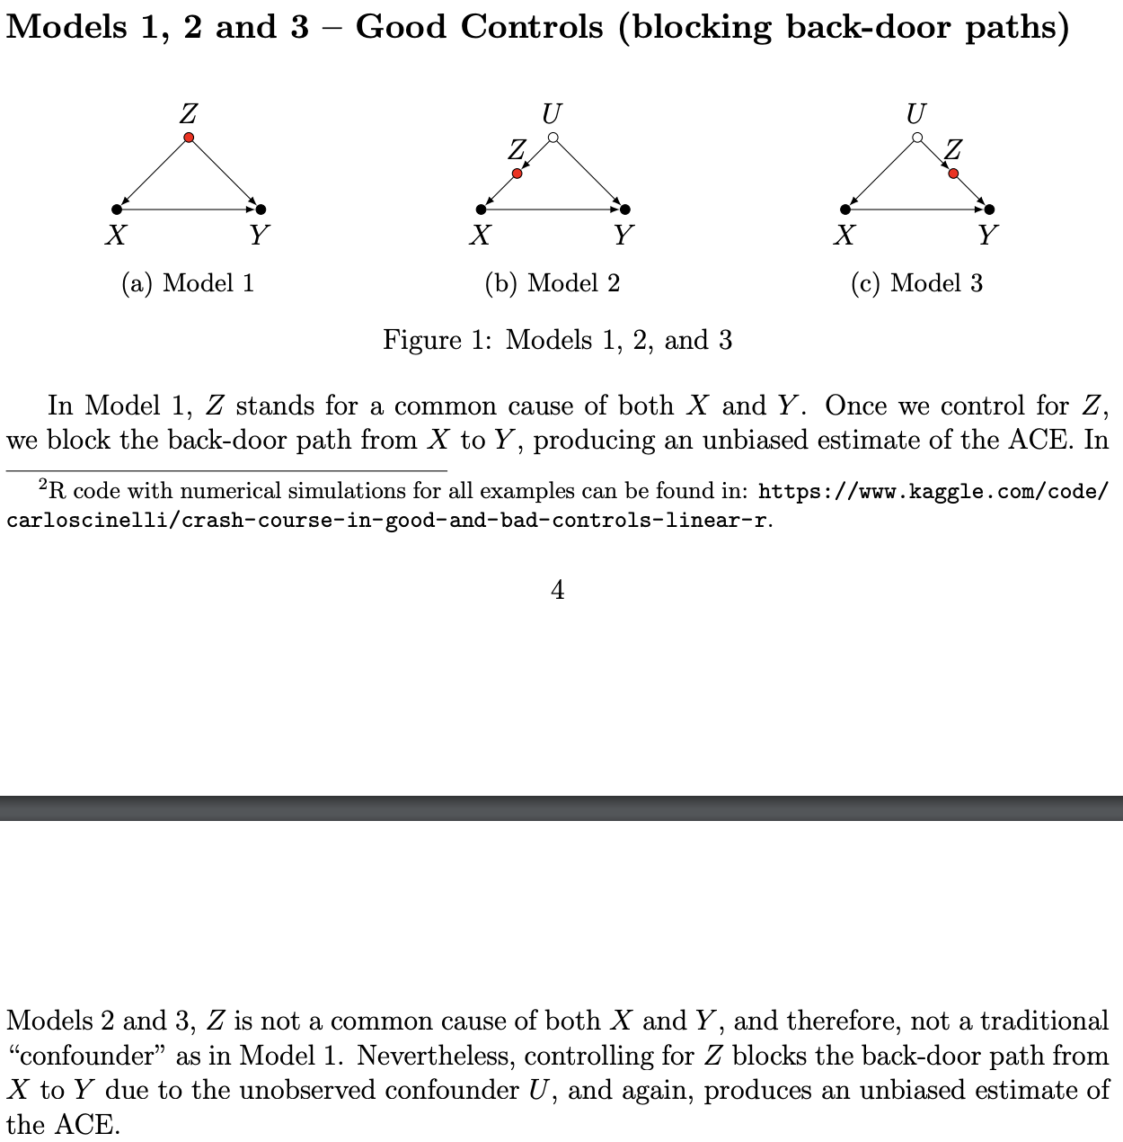

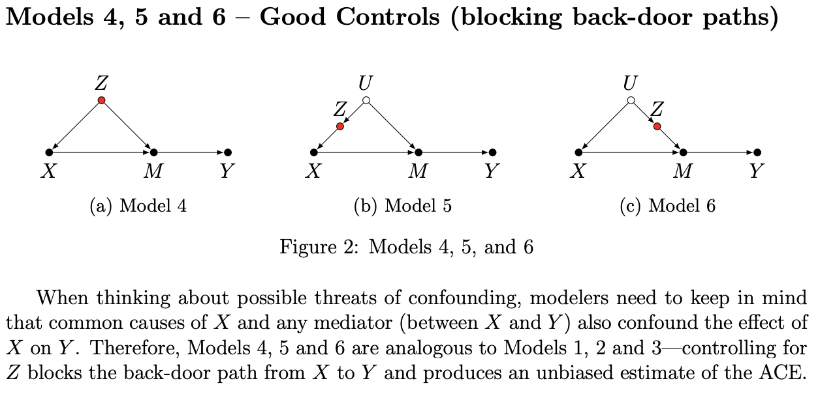

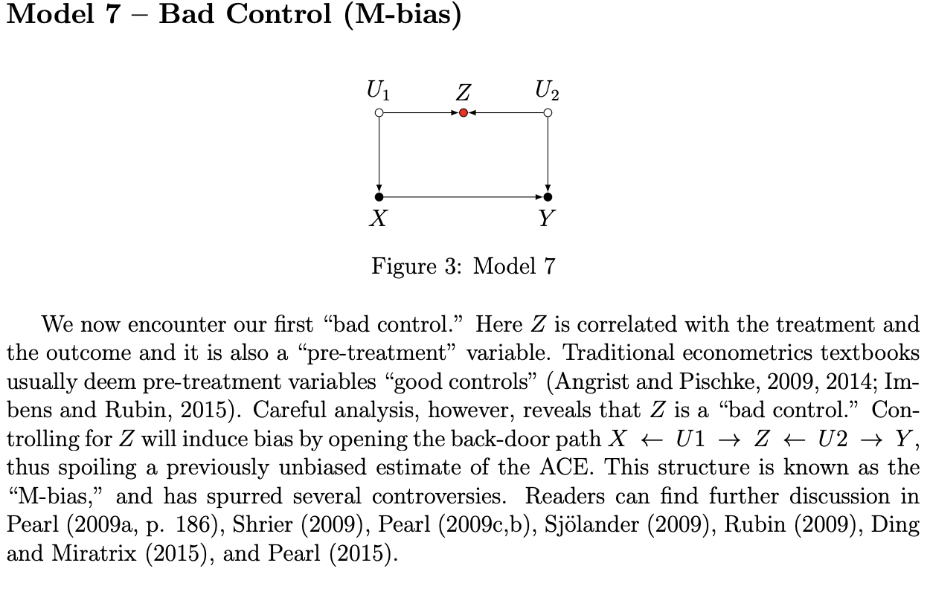

M-bias

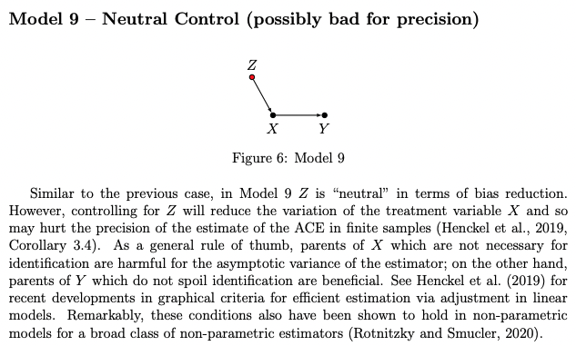

Neutral control on Z affecting X.

When considering multiple controls, the status of a single control as “good” or “bad” may change depending on the context of the other variables under consideration. Nevertheless, the main lessons from our illustrative examples remain. A set of control variables Z will be “good” if: (i) it blocks all non-causal paths from the treatment to the outcome; (ii) it leaves any mediating paths from the treatment to the outcome “untouched” (since we are interested in the total effect); and, (iii) it does not open new spurious paths between the treatment and the outcome (e.g., due to colliders). As to efficiency considerations, we should give preference to those variables “closer” to the outcome, in opposition to those closer to the treatment—so long as, of course, this does not spoil identification.

**Mensah, J., Oppong, J., Schmidt, C. “Ghana’s National Health Insurance Scheme in the Context of the Health MDGs: An Empirical Evaluation Using Propensity Score Matching,” *Health Economics,* 19, 95-106, 2010.**

In 2003 the Government of Ghana established a National Health Insurance Scheme (NHIS) to improve health-care access for Ghanaians and eventually replace the cash-and-carry system. This study evaluates an important aspect of its promise in the context of the Millennium Development Goals ]4 and ]5 which deal with the health of women and children. We use Propensity Score Matching techniques to balance the relevant background characteristics in our survey data and compare health indicators of recent mothers who are enrolled in the NHIS with those who are not.

Our findings suggest that NHIS women are more likely to receive prenatal care, deliver at a hospital, have their deliveries attended by trained health professionals, and experience less birth complications. We conclude that NHIS is an effective tool for improving health outcomes among those who are covered.

**Our interviews only included women of childbearing age (18–49 years), drawn from 2 of the 10 administrative regions of Ghana – i.e. the Brong Ahafo and Upper East regions. Rather than conducting interviews across the vast expanses of the two study regions, we purposively selected two administrative districts (one urban and one rural) from each region: the Sunyani Municipal District (urban), and the Nkoranza District (rural) in the Brong Ahafo Region; and the Bolgatanga Municipal District (urban) and the Talensi-Nabdam District (rural) in the Upper East Region. – Validity check**

**For the purposes of our analysis we concentrated on those women who responded that they had experienced a pregnancy within the last 4 years, ending either in a live birth or a stillbirth. From the perspective of the survey year 2007, this retrospective period of 4 years spans the time between the implementation of the NHIS in 2003 and the survey – validity check**

Following this, systematic random sampling was used to identify 100 respondents from each of the four selected districts to constitute a total treatment group of 400. We used a two-pronged approach to acquire our comparison group, in the absence of a sampling frame listing all the women who are nonmembers of the NHIS. First, for every treatment group member interviewed in the urban areas, we collected four comparison group members from the immediate neighborhood living north, south, east, and west of their residential location, respectively. Secondly, in small rural communities we compiled the names of all women who were not enrolled in the Scheme to serve as a sampling frame, again aiming for interviewing four potential comparison individuals. – impact?

In our study, however, we attempt to retrospectively evaluate a program that has been operating for quite some time, precluding any random assignment.

As a first step, we explore the differences between NHIS members and non-members in a wide range of personal characteristics and regional information. These characteristics are not only potential correlates of the enrolment decision but are also likely to be related to the health indicators under study. In a second step, they are serving as the principal pieces of information for constructing balanced samples of treatment and comparison observations.

While there is only a slight regional imbalance in our sample, it is evident that roughly 70% of the NHIS members relevant to our study are typically living less than 1 h commuting time from a health-care center, whereas this is the case for only under 60% of corresponding non-members. NHIS women tend to be younger and are clearly better educated than non-members. Arguably, both these characteristics tend to be important correlates of health outcomes. If we were unable to achieve balance in these covariates, the contrast between the average health outcomes of members and non-members could not be attributed reliably to the treatment. A second set of covariates that tend to influence both the decision to enrol in the NHIS and health outcomes relates to the economic situation of the respondents’ household. In our survey, we attempted to approximate the permanent income of respondents by a range of questions regarding their homes, the ownership of appliances and of means of motorized transport. Here we find considerable differences between NHIS women and those not being covered. Quite importantly, larger shares of the NHIS women had a flush toilet and pipe-borne water supply at their homes. NHIS members also had significantly more access to electricity and to electrical appliances such as TV, radio, mobile phone, computer, or refrigerator. Similarly, more NHIS members live in a household that owns a car than non-members. Finally, Table II documents a probit regression of NHIS membership on these observable characteristics. Education and some, but not all, of the permanent income variables turn out to be important predictors of NHIS membership.

NHIS women are more likely to engage with hospital care – but then couldn’t NHIS be proxy for wealth, the thing we’re trying to control for?

While our empirical results are robust to a wide range of variations in the employed econometric technique, this study is clearly limited by its non-experimental nature. Most specifically, since the questionnaire implemented a set of complicated retrospective questions, regarding episodes of pregnancy, health problems and NHIS coverage, the question of timing remains delicate. – Construct Validity issue?

We also observe that some women in our sample who enrolled in the past and were covered in the survey year 2007 had been de-enrolling temporarily in between, and, even more critical, that some non-members as of survey time had been enrolled at some time before the survey date and left the NHIS program again. If we had more precise information regarding the timing of the (temporary) enrolments and de-enrolments and on that of the last pregnancy episode(s), we would of course also probe the sensitivity of our results further along these lines. Unfortunately, our retrospective data do not allow this. Yet, before this background of imperfect individual-level data, the strong qualitative results regarding the beneficial effects of NHIS membership on a wide range of maternal and infant health indicators seem all the more impressive.

**For Presentation:**

**What is the purpose of the study?**

* To measure the effectiveness of the NHIS programme on the health of women and children whilst demonstrating various methods for balancing covariate heterogeneity to satisfy conditions for causal inference.

**What is the treatment effect?**

* NHIS Membership

**What’s the Sample?**

* 400 NHIS members, 1600 not.
* Women of childbearing age (18-49).
* From Brong Ahafo and Upper East (2 of 10 administrative regions).
* Experienced a pregnancy in the last four years.
* Between implementation of NHIS in 2003 and Survey in 2007.

**What are the potential outcomes?**

* *Not very well premised, defined, and specified.* 
  + Unsure how measures were operationalized.
* Receipt of prenatal care (Y/N)
* Deliver child at hospital (Y/N)
* Delivery attended by trained health professional (Y/N)
* Birth Complications (Y/N)
* Infant Death (Y/N)

**What are the covariates?**

* The covariates can be separated across three category specifications.
* *Geospatial Information*
  + District
  + Urban/Rural
  + Distance to health-care center
* *Personal Information*
  + Marital status
  + Religion
  + Number of pregnancies
  + Education level
* *Economic Situation*
  + Income
  + Appliance ownership
  + Utilities
  + Electronics ownership
  + Vehicle ownership

Are there any concerns regarding External Validity? Can the study’s findings be generalized to other contexts?

* Unique to region of Africa, and perhaps Ghana.

Are there any concerns regarding Internal Validity? Does the study design, conduct, and analysis answer the research questions without bias?

Are there any concerns regarding construct validity? Are measurements representative of what they intend to measure?

**Week 3: Selection on Observables 1**

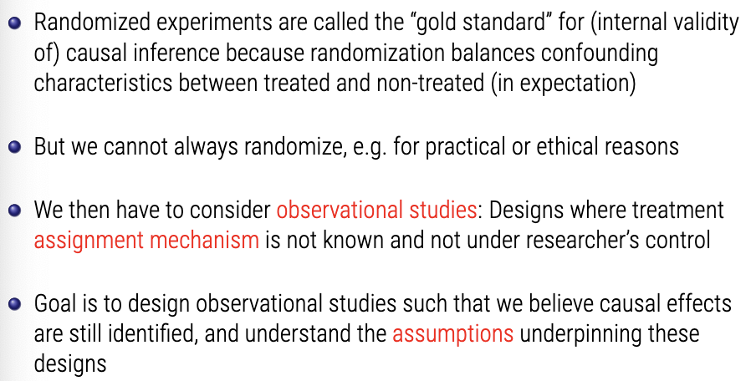

**Definition: Pre-Treatment Covariate**

*Any variable X that is predetermined with respect to the treatment D such that the value of Xi for each unit I does not depend on the value of Di.*

* This implies that there are no potential outcomes X0i and X1i with respect to this treatment D, just one value Xi which is taken as fixed for the purposes of our analysis.
* X and D may still be associated if the treatment assignment for D is associated with or causally affected y X.
* X may include characteristics that are immutable.
* X may include baseline (pre-treatment) measures of Y.

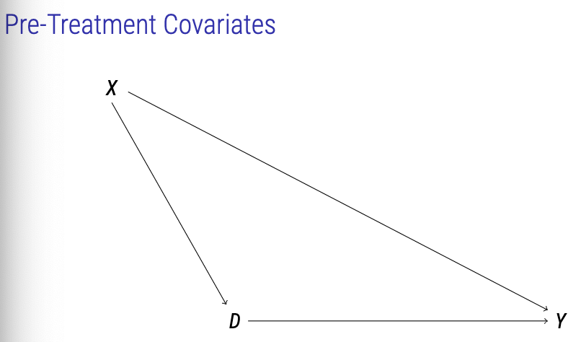

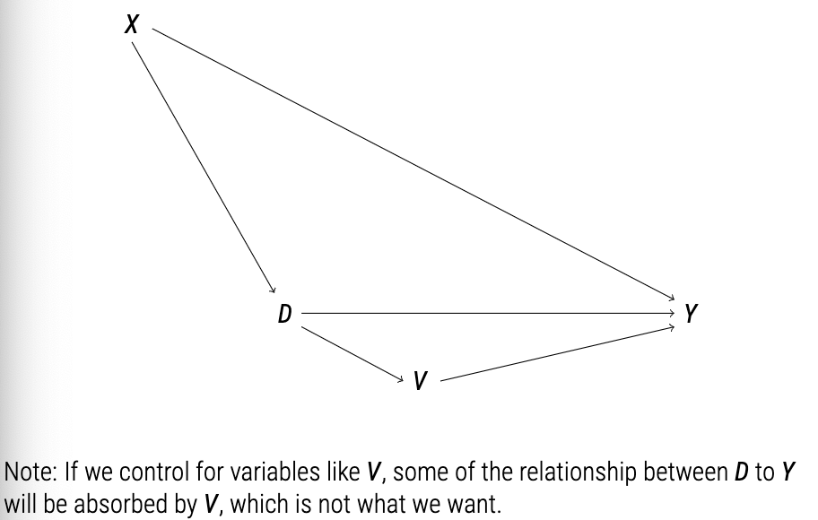

Any covariate that is post-treatment (antecedent) from the treatment. We do not want to touch this, because if we begin to change this then we’re altering the effect of D on Y.

Identification Assumptions

In randomised experiments:

* (Yi0, Yi1) independent of Di

Instead, we now make the conditional ignorability (CI) assumption:

* (Yi0, Yi1) independent of Di given that Xi = x, for any x epsilon X
* Also called exogeneity, selection on observables, no omitted variables, etc.
* So once you’re studying only those where Xi = x, CI must hold.
* Among units with identical values of Xi, Di, is ‘as-if’ random.

We also need the common support (a.k.a. positivity) assumption:

* 0 < Pr(Di = 1 | Xi = x) < 1 for any x epsilon X.
* Probability of receiving treatment for any given level of X is never 0 and never 1.

**ATE in Observational Studies**

In randomized experiments, Tau-hat is difference in means between treatment and control.

In observational studies, we use difference in the population regression functions:

* 
* Under the conditional ignorability and common support assumptions, tau is nonparametrically identified as:
* 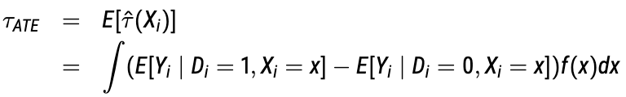
* Where the first E is taken with respect to the distribution of Xi, f(x).
* The weight is the proportion of Xi = X in the data (60% are old, 40% are young, for example). z
* This is basically a regression conditional on values of X.

**ATT in Obserational Studies**

**Tau-ATT** is also nonparametrically identified under the conditional ignorability and common support assumptions as: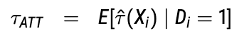

* Where E is taken with respect to the distribution of Xi given Di = 1. Note that the identification assumptions for aTT can be relaxed for the ATT.

**From Identification to Estimation**

Four broad estimation approaches:

1. Subclassification,
2. Matching,
3. Weighting,
4. Regression

**Subclassification**

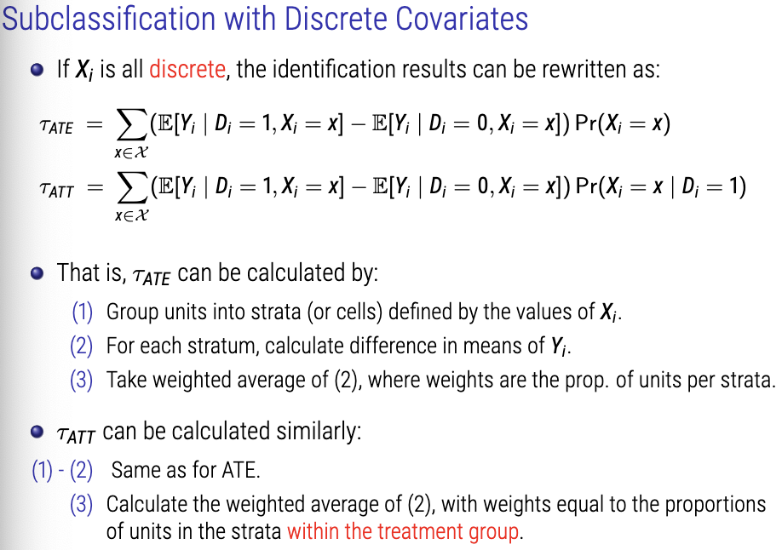

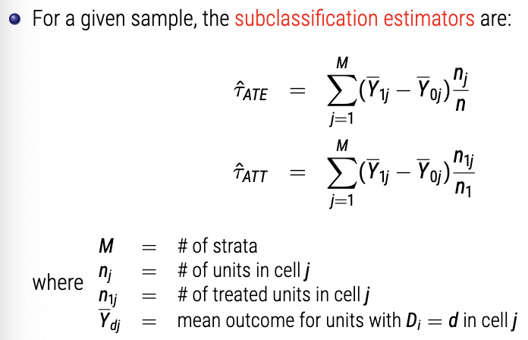

**Smoking & Mortality (Cochran 1968)**

Great example on slide 14 onwards.

**Matching**

* Subclassification only works when all covariates in Xi are discrete.
* An alternative when some/all of Xi are continuous: matching
* Basic idea: Impute missing potential outcomes using observed outcomes of ‘closest’ units.

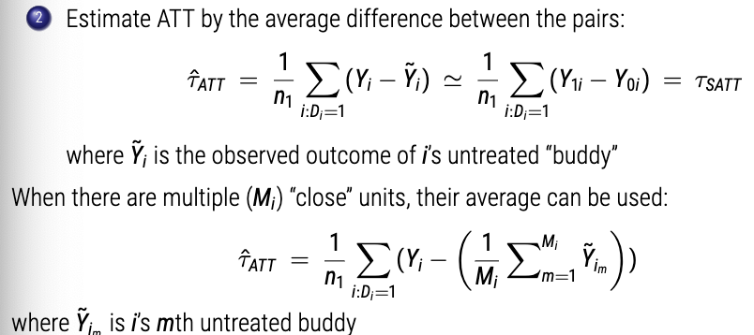

We can only try to find ATT because we’re only trying to find ‘buddies’ for the treated.

Matching with replacement is typically used.

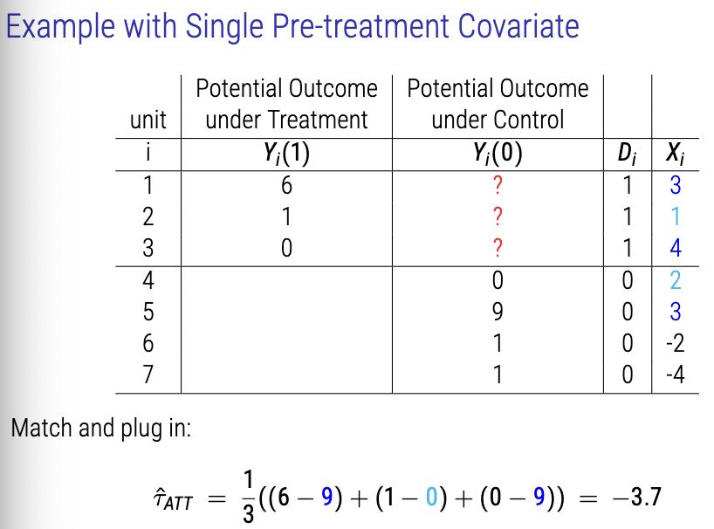

As above, matching looks like it is magic, but it’s not. Matching is an approach to estimation (just like regression). Always remember: ‘Design precedes estimation.’

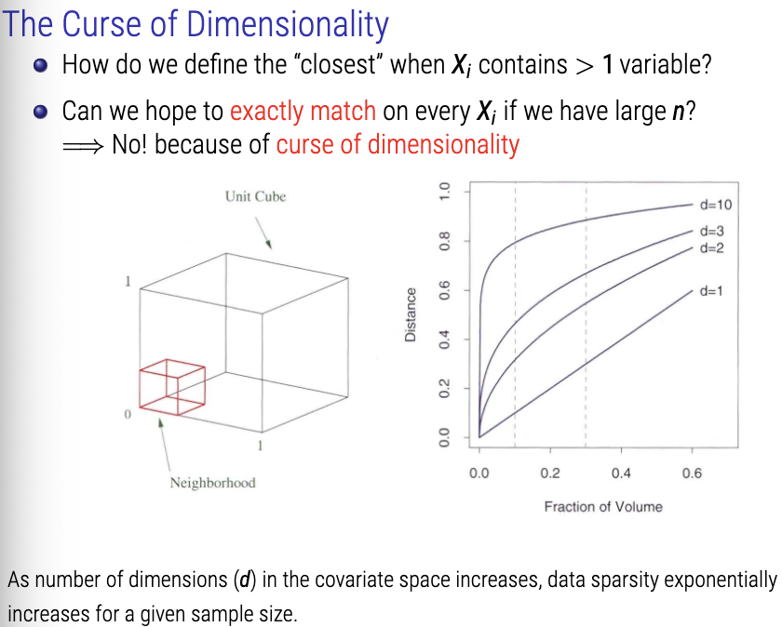

**Distance Metrics**

Every time we add a covariate for matching, we make the search problem much **bigger.**

With many covaraites, we can use a low-dimensional (usually scalar) distance metric to find the ‘closest’ match:

e.g. Mahalanobis distance:

- 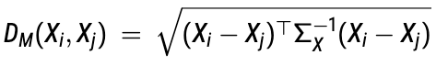

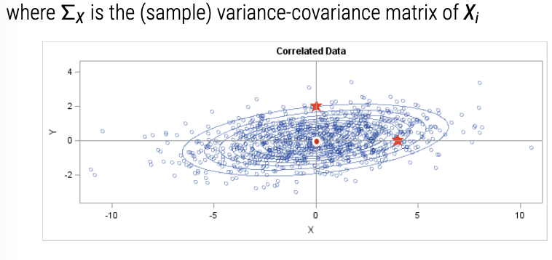

Mahalanobis distance essentially just scales Euclidean distance so not any one variable (axis) dominates smaller variances. It basically just scales variance to same.

**Definition: Propensity Score**

*Probability of receiving treatment given Xi*

* 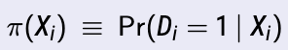

Suppose that the conditional ignorability and common support assumptions hold, the propensity score has a balancing property:

* Di independent on Xi given | pi(Xi)
* Among those units with the same propensity score, Xi, is independent of treatment assignment.

BUT there is a catch:

* We need to estimate Pi(Xi) in two steps. Pi(Xi) is the match.

1. Estimate pi(Xi) with a model for a binary response
2. Do nearest neighbour matching on Pi(Xi)
   1. Note: need to allow some uncertainty from (1) to percolate through to (2).

How do you actually do it?

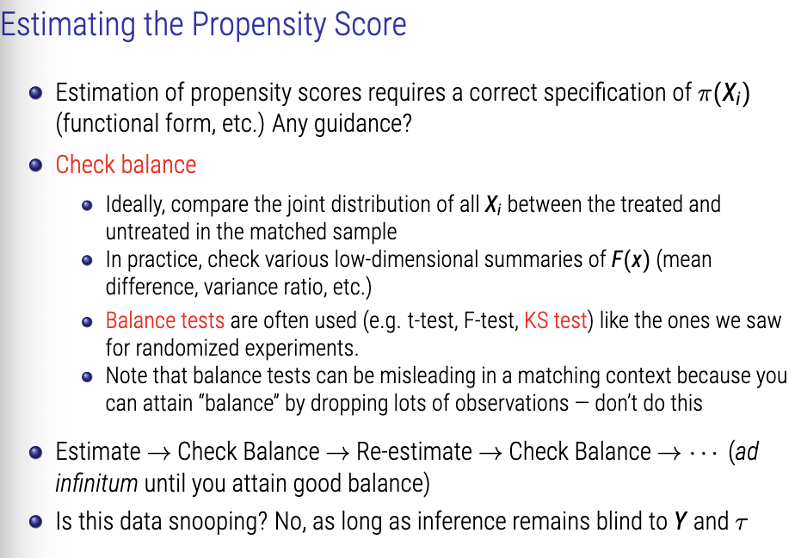

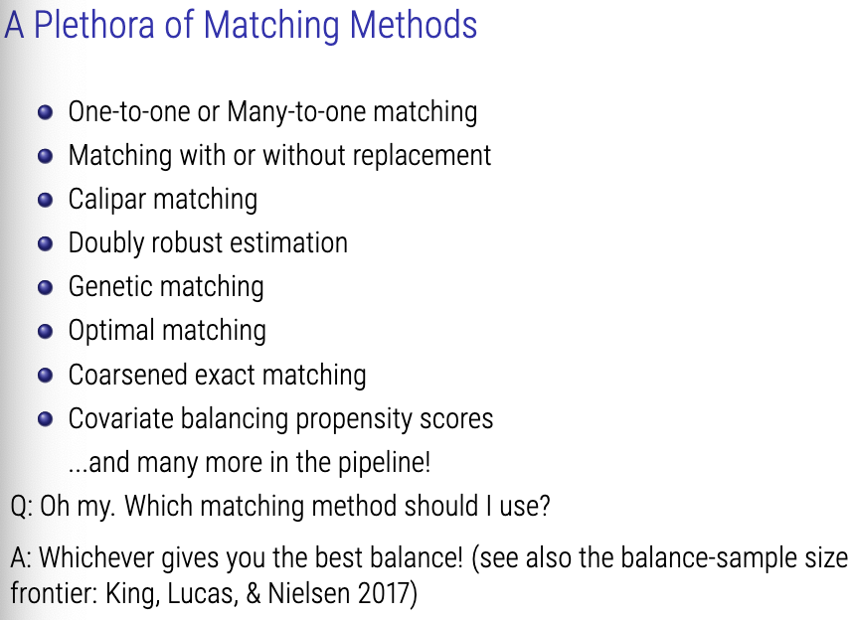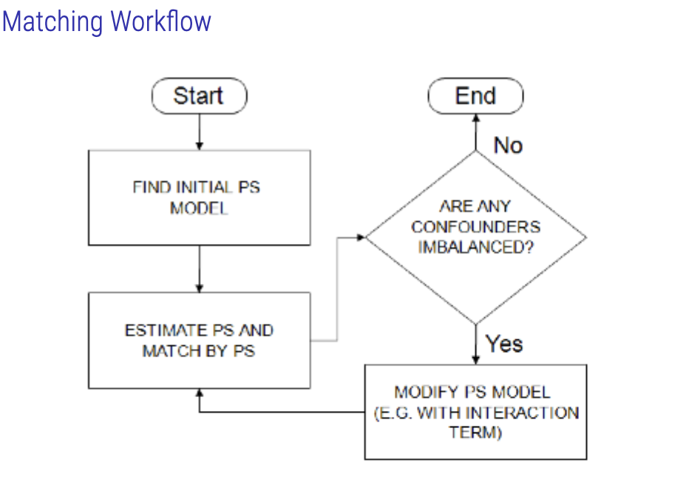

**Hernán, M. A. and Robins, J. M.**[**Causal Inference: What If**](https://www.hsph.harvard.edu/miguel-hernan/causal-inference-book/)**.**

***Ch 2.3: Standardization***

When, as here, a counterfactual quantity can be expressed as function of the distribution (i.e., the probabilities) of the observed data, we say that the counterfactual quantity is identified (or identifiable); otherwise, we say it is unidentified.

This method is known in epidemiology, demography, and other disciplines as standardization. For example, the numerator 􏰂l Pr[Y = 1|L = l,A = 1] Pr [L = l] of the causal risk ratio is the standardized risk in the treated using the population as the standard. Under conditional exchangeability, this standardized risk can be interpreted as the (counterfactual) risk that would have been observed had all the individuals in the population been treated.

The standardized risks in the treated and the untreated are equal to the counterfactual risks under treatment and no treatment, respectively.

**Braghieri, L., Levy, R., Makarin, A. “Social Media and Mental Health,” *American Economic Review,* 112(11), 3660-3693, 2022.**

* **ITT not ATT, as we only measure whether the college had access to Facebook, not whether the student had an FB account.**
* The strategy compares the before-after difference in outcomes between students in colleges where Facebook was introduced and students in colleges that did not change their Facebook status between the two periods
* **As a baseline specification, we estimate the following two-way fixed-effect (TWFE) model: **
  + where Yicgt represents an outcome for individual i who participated in survey wave t and attends college c that belongs to expansion group g; αg (or sometimes αc) indicates expansion-group (or college) fixed effects; δt indicates survey-wave fixed effects; Facebook-gt is an indicator for whether, in survey wave t, Facebook was available at colleges in expansion group g; Xi and Xc are vectors of individual-level and college-level controls, respectively.
* We estimate equation (1) using **ordinary least squares** (OLS) and **cluster standard errors** at the college level.
* Estimate event-study version of TWFE model to test for parallel trends
  + 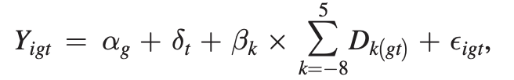
  + where Yigt is our index of poor mental health and Dk(gt) is set of indicator variables that take value one if, for expansion group g in survey wave t, the introduction of Facebook was k semesters away. When estimating the model using OLS, we treat students who took the survey in the semester just before Facebook was rolled out at their college as the omitted category and compare them to students who took the NCHA survey in other semesters.
  + Heterogeneity by Predicted Susceptibility to Mental Illness.—In order to study whether the introduction of Facebook at a college led students on the margin of a depression diagnosis to take up depression-related services, we proceed in two steps: first, we estimate a least absolute shrinkage and selection operator (LASSO) to identify individuals who, based on baseline immutable characteristics, are more susceptible to mental illness. Second, we show heterogeneous treatment effects based on our LASSO-predicted measure of susceptibility to mental illness.
  + The LASSO prediction is generated as follows: first, we construct an indicator that equals one if a student has ever been diagnosed with a mental health condition. Second, we consider a set of immutable individual-level characteristics (age, year in school, gender, race, an indicator for US citizenship, and height), generate all two-way interactions between these characteristics, and generate second- and third-order monomials of each characteristic. Third, we implement a LASSO procedure in the preperiod to predict our indicator for ever having been diagnosed with a mental health condition based on the immutable individual-level characteristics and functions thereof described above.
* To the extent that, in the absence of the Facebook rollout, the mental health outcomes of students attending colleges in different Facebook expansion groups would have evolved along parallel trends, and assuming college-level average treatment effects are homogeneous across treated colleges and over time, the coefficient of interest β identifies the **average treatment effect on the treated (ATT)** of the introduction of Facebook on student mental health.
* uction of Facebook on student mental health. Under the assumptions from the previous paragraph, the TWFE model allows us to rule out various concerns that could otherwise impair our ability to interpret the results as causal. First, we can rule out that the results are driven by time-invariant differences in mental health across colleges. Specifically, one could worry that more selective colleges recruit wealthier students who may have better (or worse) baseline mental health outcomes. By including Facebook-expansion-group or, depending on the specification, college fixed effects we can rule out such concerns. Second, we can rule out that our results are driven by mental health outcomes evolving over time in a way that is common across students at different colleges. For instance, certain macroeconomic fluctuations might influence all students’ job prospects in a similar way, and, in turn, affect their mental health. Survey-wave fixed effects allow us to rule out such concerns
* **A critical issue is the plausibility of the parallel trends assumption.**
  + one might worry that colleges belonging to different Facebook expansion groups might be on different mental health trends.
  + Addressed in 4 Ways
    - First, we estimate a fully dynamic version of equation (1) and check for potential pre-trends.
    - Second, we explore the existence of pre-trends by estimating a fully dynamic version of the alternative estimators introduced in prior texts.
    - Third, to the extent that the trends are linear, we would be able to account for them in a robustness check that includes expansion-group-level linear time trends.
      * What if not linear?
    - Fourth, we present results using a specification that does not rely on
    - our baseline college-level parallel trends assumption. In particular, we present results using a specification that includes college × survey-wave fixed effects and that compares students within the same college-survey wave who were exposed to Facebook for different lengths of time based on the year in which they entered college.
* **Limitations**
  + Although TWFE regressions similar to equation (1) are the workhorse models for staggered adoption research designs, they have been shown to deliver consistent estimates only under relatively strong assumptions about homogeneity in treatment effects.
    - The treatment effect estimate obtained from a TWFE model is a weighted average of all possible 2 × 2 difference-in-differences comparisons between groups of units treated at different points in time. If treatment effects are homogeneous across treated groups and across time, the TWFE estimator is consistent for the ATT. Conversely, if treatment effects are heterogeneous across groups or time, the TWFE estimator does not deliver consistent estimates for the ATT.
      * We address concerns about the reliability of TWFE estimator by replicating our results using the robust estimators introduced in De Chaisemartin and d’Haultfoeuille (2020); Borusyak, Jaravel, and Spiess (2021); Callaway and Sant’Anna (2021); and Sun and  Abraham (2021). By shutting down the 2 × 2 difference-in-differences comparisons between newly treated and already treated units, the robust estimators deliver consistent estimates even in the presence of heterogeneous treatment effects across time and/or treated units.
* **Results**
  + 4 models – all statistically significant negative impact of SM on MH.
    - Only fourth model satisfies parallel trends assumption, though?
      * This is also the model with the lowest ‘ATT.’
    - The effect above is estimated on the entire population of students taking the NCHA survey, which includes both students who did and who did not sign up for a Facebook account after Facebook was made available at their college. Therefore, the point estimate captures both the direct effect of Facebook on students who joined the platform and the indirect effect of Facebook on students who did not join the platform, but whose peers did. Although **we cannot separate these two channels** in the absence of data on an individual’s Facebook use, we note that it is unlikely that our results are primarily driven by students who did not have a Facebook account.
    - As a final benchmark, we leverage additional assumptions to compare our results to long-run mental health trends. The effect we find on the share of students who suffered from severe depression at least once in the last year is approximately 24 percent of the increase in that share between 2000 and 2019.22 This number can be interpreted as the fraction of the increase in the prevalence of severe depression among college students that is explained by Facebook. Such calculation relies on strong assumptions and should therefore be interpreted with caution. Specifically, we assumed that (i) **Facebook utilization rates among college students did not change substantially after 2004–2005;** (ii) the effects of Facebook did not change over time; (iii) Facebook does not have cumulative effects.
      * **This is an issue. We know that Facebook usage amongst students is different in 2019 to 2010. Facebook is for old people!**

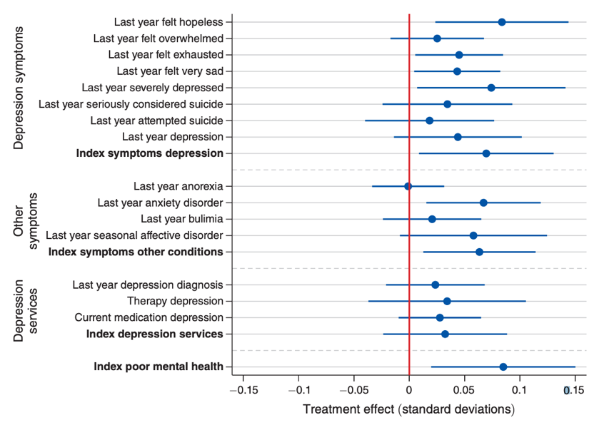

* + Heterogeneity by Predicted Susceptibility to Mental Illness.—In order to study whether the introduction of Facebook at a college led students on the margin of a depression diagnosis to take up depression-related services, we proceed in two steps: first, we estimate a least absolute shrinkage and selection operator (LASSO) to identify individuals who, based on baseline immutable characteristics, are more susceptible to mental illness. Second, we show heterogeneous treatment effects based on our LASSO-predicted measure of susceptibility to mental illness.
    - Those who are predicted to be most susceptible to mental illness are indeed significantly more likely to take up depression-related services.
    - the estimates are consistent with the parallel trends assumption: independently of the estimator used, the coefficients on the semesters prior to the introduction of Facebook at a college are all close to zero and exhibit no discernible pretrends.
    - all the recently developed robust estimators show treatment effects that increase over time in the postperiods
    - The increase in treatment effects over time could be explained by (i) higher adoption rates at a college over time; (ii) higher intensity of usage at the individual level over time; (iii) the effects becoming stronger as a function of length of exposure to the platform.

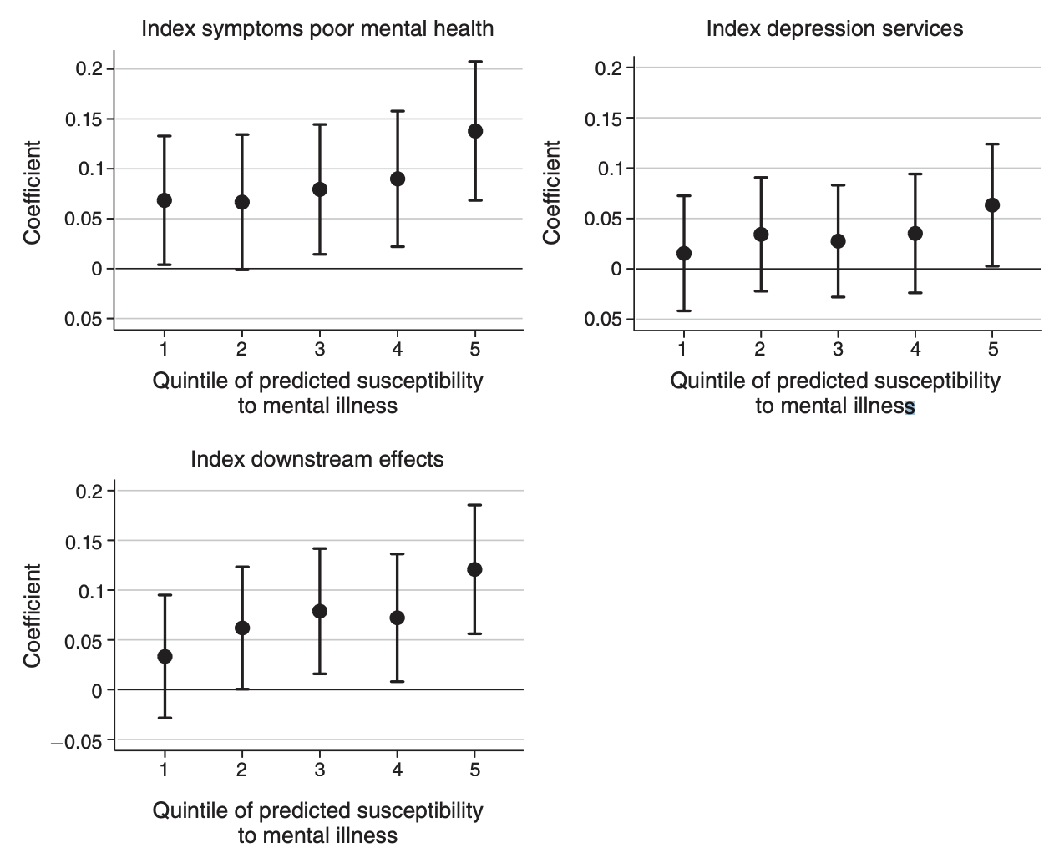

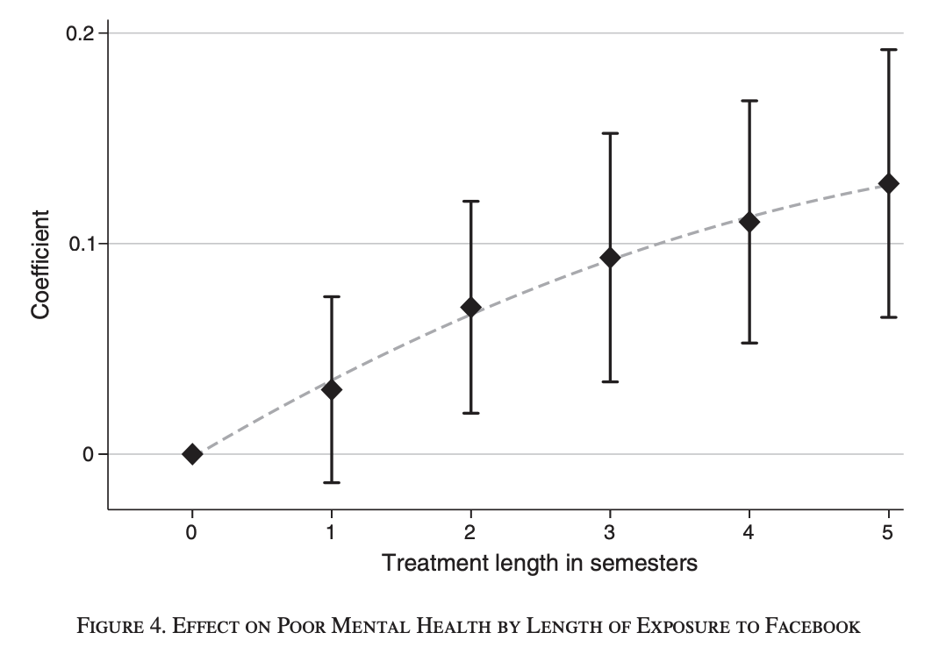

* **Performed many robustness checks for following:**
  + Stigma as an Alternative Explanation.
    - the introduction of Facebook did not affect the reporting of other stigmatized conditions.
  + Downstream Implications of Poor Mental Health
    - after the introduction of Facebook, students were more likely to report that their academic performance was impaired as a result of poor mental health.
* **Prefer ‘Unfavourable Social Comparisons’ as probable mechanism over ‘Disruptive Internet Use’ and ‘Other behaviours’ mechanisms.**
  + Students who live off campus more affected
  + Students who have weaker offline social networks (no frat/sorority membership)
  + Students with more credit card debt or are working alongside studying
  + Students who are overweight
* Despite these caveats, we believe the estimates presented in this paper are still highly relevant today for two main reasons.
  + First, the mechanisms whereby social media use might affect mental health arguably relate to core features of social media platforms that have been present since inception and that remain integral parts of those platforms today.
  + Second, the mechanisms whereby Facebook use can affect mental health might have been exacerbated rather than mitigated by many of the technological changes undergone by Facebook and related platforms in the last 15 years.

**Seminar Commentary:**

**Week 4: Selection on Observables 2**

Studying observational settings where the assignment mechanism for D is either unknown or not under our control...

*But* we are willing to make the conditional independence assumption:

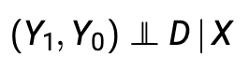

given some set of observed pre-treatment covariates X.

**Essentially, we are assuming that once we condition on X, then the assignment of D is “as good as random.”** Remember, this is is a demanding and largely unverifiable assumption!

We consider 4 broad approaches which rely on the conditional independence assumption:

1. Subclassification,
2. Matching,
3. Weighting,
4. Regression

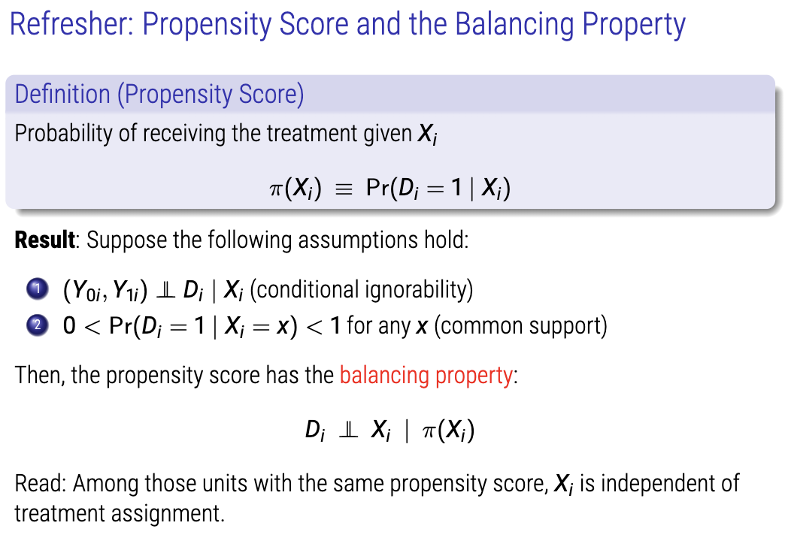

**Matching**

Among units for same propensity score, the propensity score has a balancing property which *balances* between treatment and control.

We identify the closest match in the control group on the basis of propensity score for a member of the treatment group.

**Weighting**

Propensity score weighting assigns patients different “weights”—weighting them up or down to make the patients in the treatment group and the comparison group more similar to each other.

Propensity score weighting allows you to leverage information from all patients included in your sample. Also called **‘Inverse Probability Weighting.’ (IPW)**

Weights determine how much each observation contributes to final estimands.

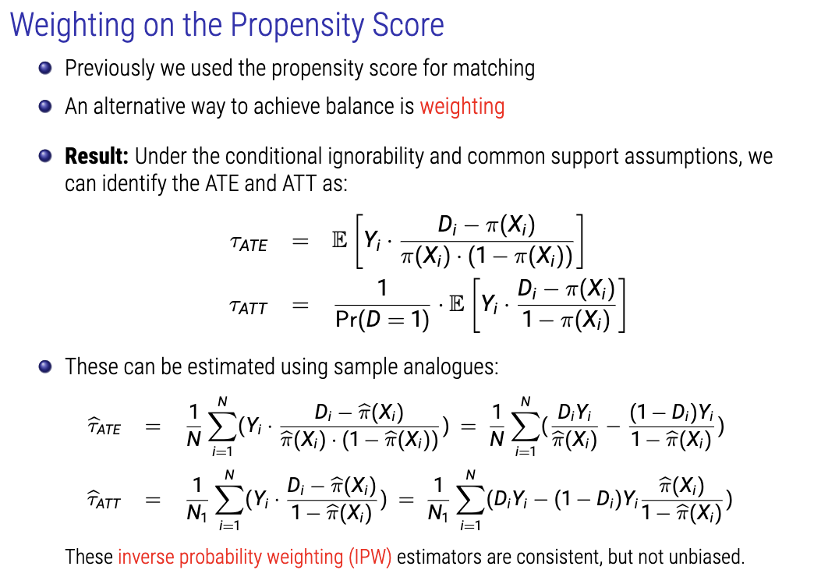

**Performance of the IPW estimators**

IPW estimators are consistent but biased in small samples. How bad are their small sample biases? It turns out the bias is substantial when some weights are extremely large or small.

Weights tend to be extreme when there is a lack of overlap. A simple workaround is trim units with extreme weights, but this changes the estimand to a quantity that is still causal yet difficult to interpret.

Alternative weighting methods with preferable finite sample properties include:

* Augmented IPW: doubly robust estimator (more later).
* Entropy balancing (Hainmueller 2012)
* Choose weights that directly optimize (observed) covariate balance.
* Covariate balancing propensity scores (Imai and Ratkovic 2014)

**Model-based Estimation of Causal Effects**

We can also adjust for covariates through a parametric model, Regression.

* When we think of “controlling for” variables, we usually think of regression. But what role can it play in causal inference?
* Recall that under conditional ignorability and common support, ATE/ATT equal weighted averages of the differences in population regression function:



**where**



This suggests a model-based approach for estimating causal effects, where we

use a regression model for E[Yi |Di, Xi], e.g.,

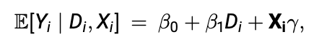

which is a linear regression, and we can estimate βeta-1 via OLS. What could go wrong with this approach?

**OLS as an Estimator of Causal Effects**

Suppose we regressed Yi on Di and Xi, estimating the coefficient on Di via OLS:

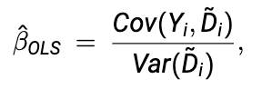

Where D-squiggly-i is the residual from the regression of Di on Xi (‘partialling out’).

Question: When is Beta-hat-OLS a good estimator of Pi-ATE?

The answer depends on whether these two assumptions hold:

1. constant treatment effect: Tau = Y1i – Y0i for all i.
2. Linearity: Potential outcomes can be written as linear additive equation for d = 0, 1.

Noting that (2) implies (1), there are 3 possible scenarios:

1. Both 1 & 2 are true.
2. Only 1 is true.
3. Neither are true.

**Case 1: Constant Effect w/ Linear Potential Outcomes (Both 1 & 2 are true).**

Result: If treatment effect is constant across units and potential outcomes are linear in Xi, then the OLS estimate of β1 in the following regression model:

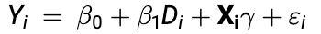

Is an unbiased and consistent estimator of Pi-ATE.

Proof:

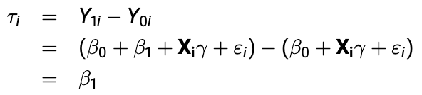

Next, note that conditional ignorability implies the conditional independence between Di and εi. Because this implies the zero conditional mean assumption, Beta-hat-OLS, is an unbiased and consistent estimator of Beta-1 which is equal to Pi-ATE (and Pi-i).

**Case 2: Constant Effect w/ Unknown Functional Form (Only 1 is true)**

Linearity is a very strong assumption in many ‘Selection on Observables’ situation.

What if Yi(d) is an unknown nonlinear function of d and Xi, and yet we used Beta-hat-OLS as an estimator of Pi-ATE anyway?

Beta-hat-OLS still gives us the best linear approximation to the population regression function (minimising MSE), even if we have misspecified (it isn’t linear in reality).

The result will be as follows:

* Beta-hat-OLS can be legitimately interpreted as the best linear approximation to the true treatment effect, whatever the true functional form is.
* This approximation may or may not be good in absolute terms.
* More flexible models may provide a better performing approximation.

**Case 3: Non-constant Treatment Effects (Neither 1 or 2 are true)**

What if treatment effects vary across units? Treatment effect heterogeneity

When would bottom equation be high (in red)?

When a specific value of x subgroup of interest has way more variance in D than the average of all subgroups of X.

OLS will upweight those units for which there is a lot of variance in D.

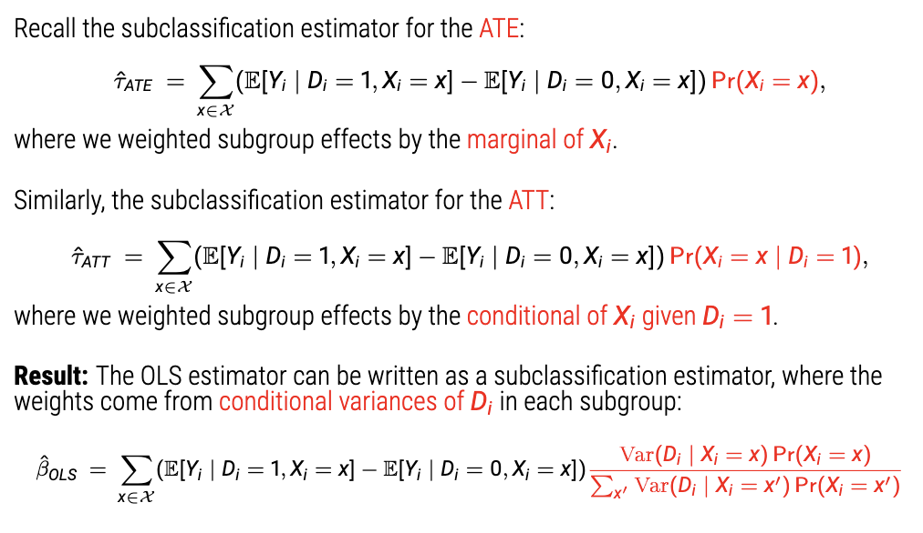

We can rewrite OLS estimator as subclassification estimator, with weights from conditional variances of Di in each subgroup.

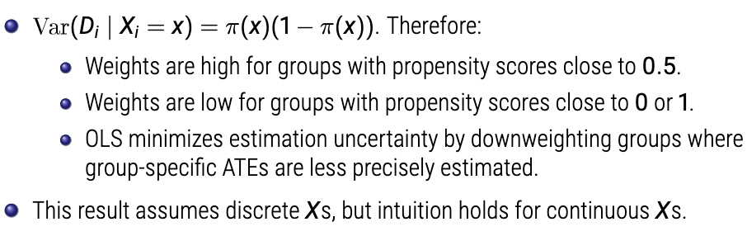

If we don’t control for differing distributions of X across the data, we misguide our estimator (bias). With non-constant treatment effects, OLS provides an unbiased estimator of conditional-variance-weighted ATE. This is a causal quantity, but hard to interpret. It is not generally equal to the ATT or ATE (more in a moment).

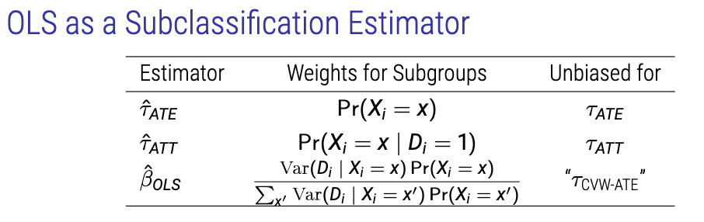

**OLS as a Weighted Average of Estimands**

Under some assumptions, given heterogenous treatment effects, the causal estimands targeted by OLS is:

*Tau-OLS = W1*Tau-ATT + W0*Tau-ATU*

Where:

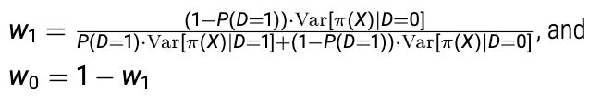

With non-constant treatment effects, OLS can be an unbiased estimator for a weighted average of the ATT and ATU.

This admits a strange interpretation:

1. Weights Wj are inversely proportional to the share of units j!
2. This is weird: if you have a lot of treated units, ATU will be upweighted and ATT downweighted.
   1. For the ATT, OLS is predicting the missing potential outcomes for the treated – those come from the coefficients for the control, so these are upweighted.

**Fully-Interacted Estimator**

Well regarded large-sample linear regression estimator is as follows:

1. For every covariate, you de-mean the covariate (normalised)
2. Multiply those de-meaned covariates by D.

Where:

1. Xi are covariates sufficient to satisfy the conditional independence assumption
2. X-head is the sample mean of Xi.

Why?

1. Differentiates how D differs relative to levels of X to get past the constant treatment assumptions.
2. Lets Tau vary by levels of X.

|  |  |  |
| --- | --- | --- |
| **Method** | **Pros** | **Cons** |
| **Matching** | 1. Non-parametric (no model dependence), 2. Can be a transparent way to move from data/design to an estimate. | Recall that because we can very rarely ever exactly match, matching usually  induces bias by pulling our estimate slightly away from the estimand. This  becomes more severe:   1. The more matches for each treated unit, 2. The more covariates we match on. |
| **Regression** | Simple | 1. In ‘Selection on Observables’ world, regression relies on a number of strong assumptions to admit a readily interpretable estimate. 2. Regression is prone to extrapolation beyond common support. |

**Combining Regression, Matching and Weighting**

* Bias-corrected Matching (Abadie and Imbens, 2005):
  + Estimate bias inherent to matching estimators via regression.
  + Subtract it off from the matching estimate for correction.
* Double-robust Estimation (Robins & Rotnitzky 2001):
  + Use a weighted average of regression and IPW estimators
  + The estimator will be consistent as long as either the regression model or prop score model is correct
* Matching as nonparametric data preprocessing (Ho, Imai, King & Stewart; 2007):
  + Model-based estimation of causal effect is most likely to go wrong when it involves extrapolation due to poor overlap in covariates.
  + Use matching to make treatment and control groups similar.
  + Then run regression models to estimate causal effects.

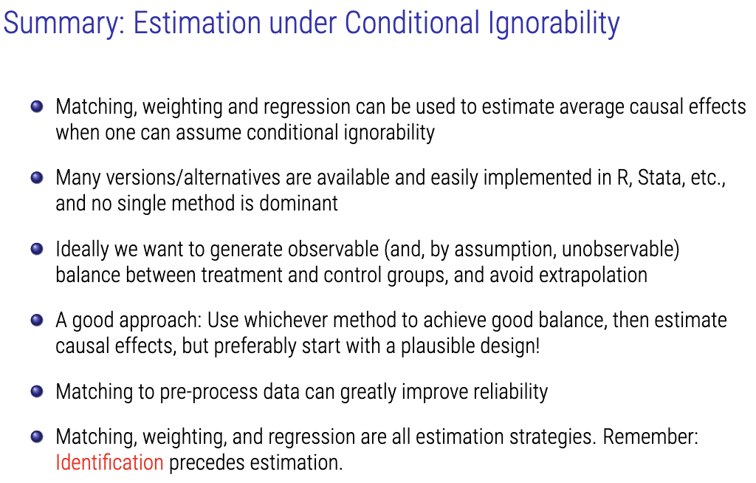

**IDENTIFICATION PRECEDES ESTIMATION.**

**Lecture 5: Difference-in-Differences Part 1**

**Previously, we assumed selection on observables: We have measured and accounted for all confounding variables. This is a very strong assumption, and is rarely defensible or plausible. Often, treated, and untreated units will differ in unobservable characteristics that are associated with potential outcomes, even after controlling for observables. With variation in treatment over two dimensions – between units and over time – we can control for certain unobservables, even without measuring them explicitly. This is difference-in-differences. We will require new assumptions that are often more (and very rarely *less)* defensible.**

**Difference-in-Differences**

Difference-indifferences is a powerful, widely applicable design that has received renewed attention in recent years. Used in both social science and industry – wherever there is variation in treatment over both time and one other dimension. This is very common!

Today, we will focus on the canonical 2-period difference-in-differences design, with a brief extension to two pre-treatment periods. Next week we will extend this design to multiple time periods with (potentially) staggered treatment roll-out and (potentially) heterogeneous treatment effects.

**Example: Card & Krueger (1994) Minimum Wage and Employment**

Survey data on wages and employment from two waves:

* Wage 1: March 1992, one month before minimum wage increase
* Wave 2: December 1992, Eight months after increase

**Outcomes – Potential & Observed**

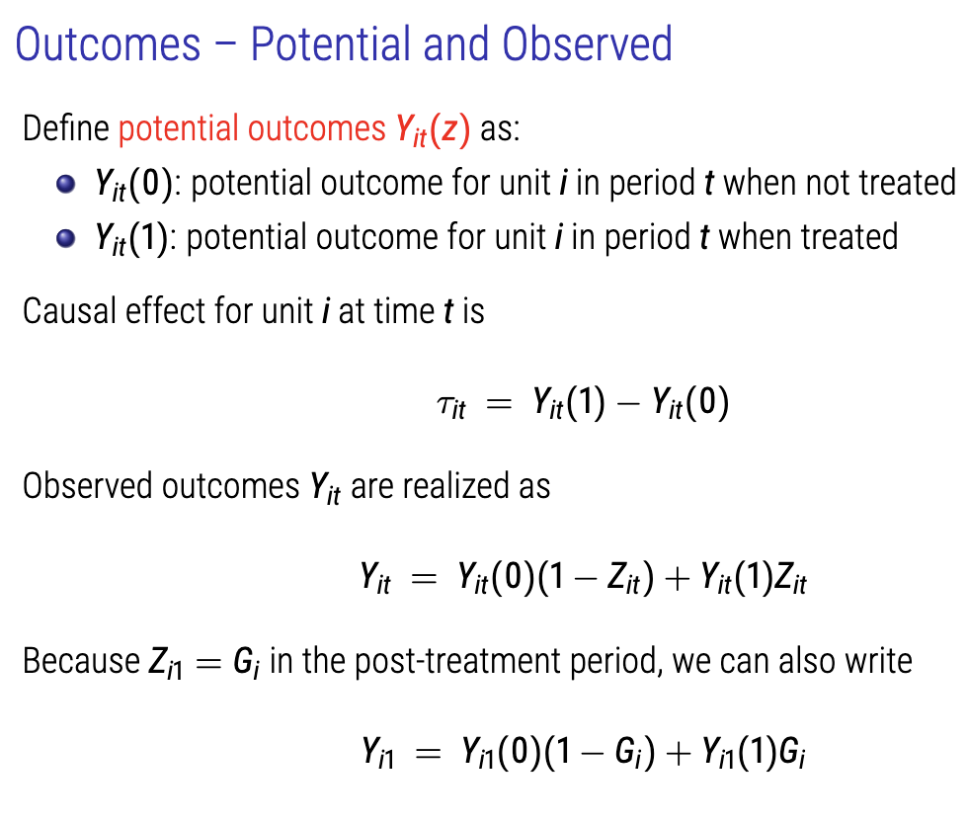

**Identification Strategies**

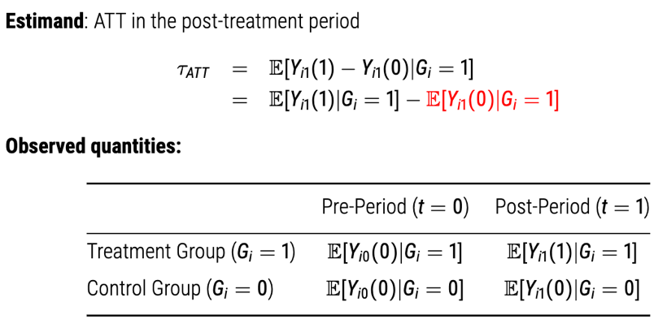

**Problem:** Missing potential outcome, E[Yi1(0)|Gi = 1] i.e., what is the average post-period outcome for the treated group in the absence of the treatment?

**1ST Dimension of Variation: Temporal Change**

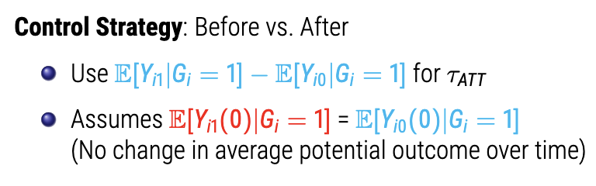

**2nd Dimension of Variation: Unit-level Change (treatment assignment)**

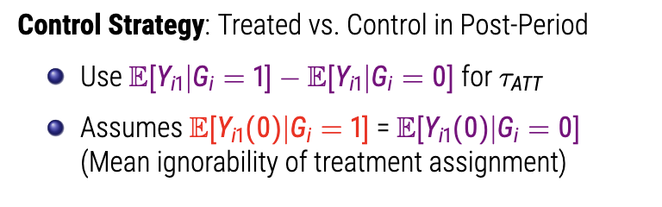

**Combined: Accounting for 2D Variation w/ Difference-in-Differences**

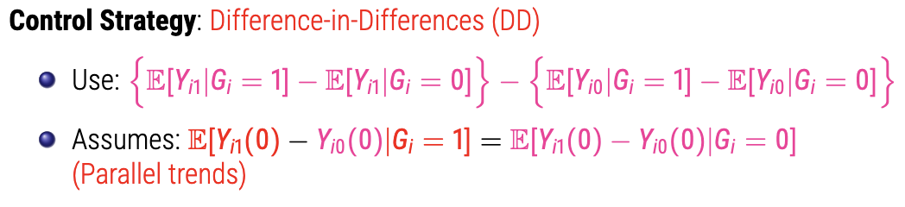

**We’re assuming that the two units would have trended the same had the treated unit not been treated.**

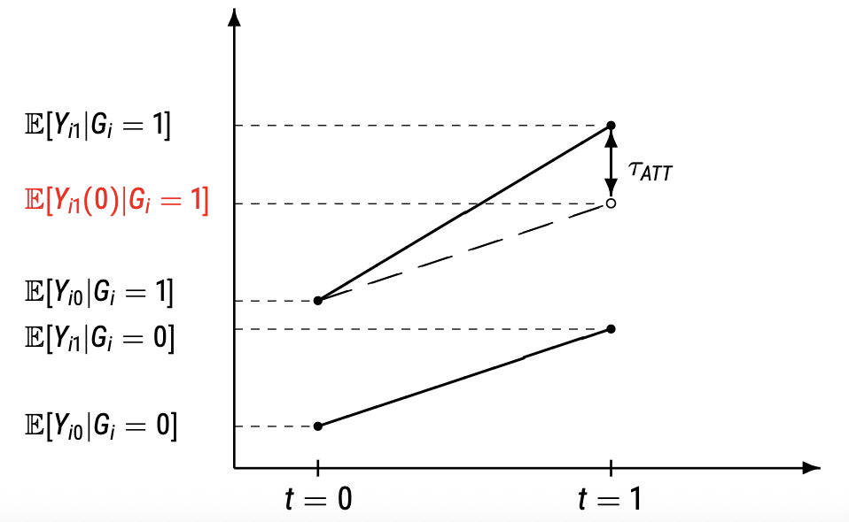

Because we cannot observe the potential outcome under parallel trends – we need to search for clues to discern the plausibility of the parallel trends’ assumption.

What type of confounding does diff-in-diff make us robust to?

1. Unobserved confounding that is time-invariant and additive.
   1. Unit-level
2. Unobserved confounding that is time-varying.
   1. For example – a period of 3 years between pre and post-treatment is different for those between 18 and 21 compared to 45-48.

Adding pre-treatment covariates makes us turn to the conditional parallel trends assumption, which asks us to assume parallel trends within strata. So, in the above (age) example, we might control with covariate for age to transition from parallel trends to conditional parallel trends assumptions.

Note: the parallel trends assumption is not invariant to nonlinear transformations of the outcome scale. For example, parallel trends in Yit(z) implies non-parallel trends in log(Yit(z)) and vice versa.

**Panel vs. Cross-Sectional Data**

**Panel**

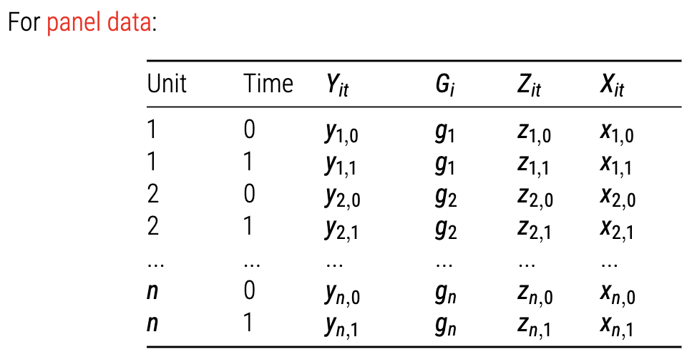

A plug-in **estimator** is‘difference in difference-in-means.’ Standard errors can be estimated by extending the diff-in-means variance formula using the same logic (assuming no clustering).

**w/ Regression**

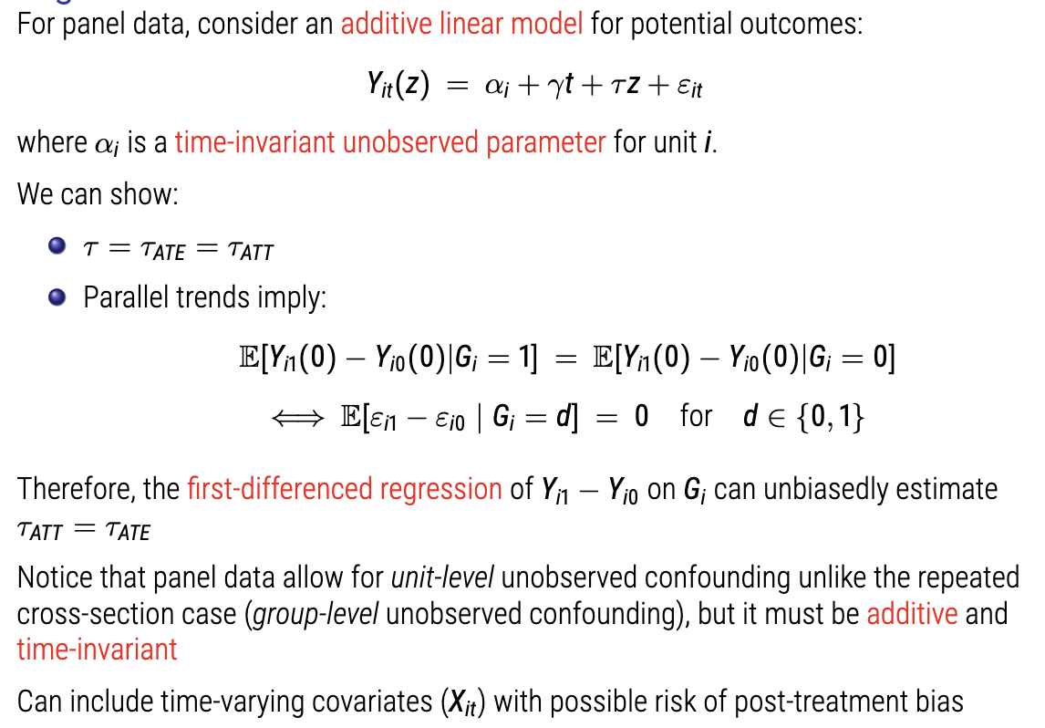

This implies that:

1. Error terms are stable over time.
2. Tao effect is homogenous treatment effect

**Repeated Cross Sections**

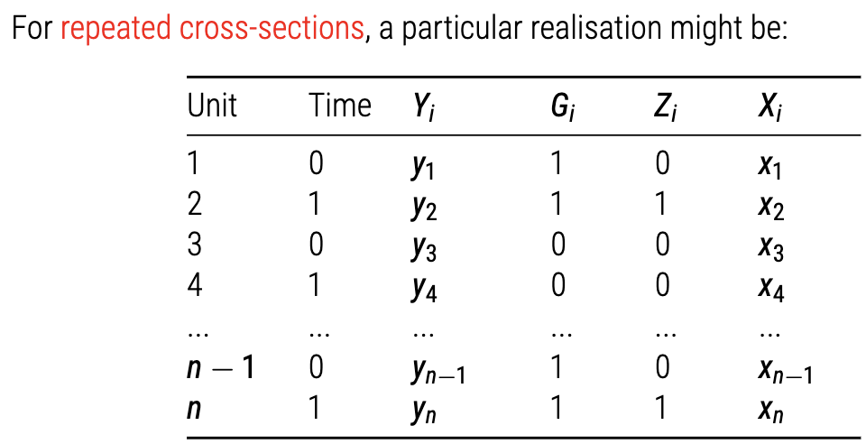

**w/ Regression**

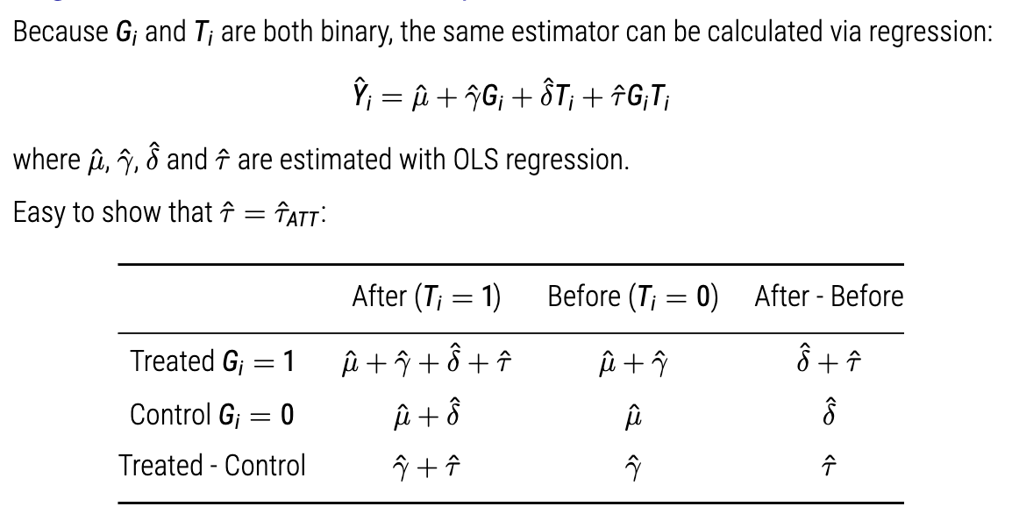

As above – the interaction (tauhat*Gi*Ti) is the estimator with causal interpretation.

**A Note on Inference**

* Treatment assignment may or may not be assigned at the unit level. In some cases, it is assigned in a clustered fashion:
  + Geographic assignment (NJ Minimum Wage)
  + Grouped assignment (e.g. schooling interventions)
* Standard errors should account for the level of assignment – if clustered assignment, cluster SEs
* If you have small number of clusters (< 30), consider a bootstrapped alternatives.

**Testing Parallel Trends**

Obviously, we cannot directly test parallel trends as we never observe potential outcomes.

However, assuming we have two time periods (T = 2), we can test for parallel pre-trends:

* Through discrete analyses:
  + Generate placebo treatment indicators before true treatment occurs, and test for ‘effect.’
* Event-study model:
  + Fully interact treatment with time period dummies, which generlaises the above idea.

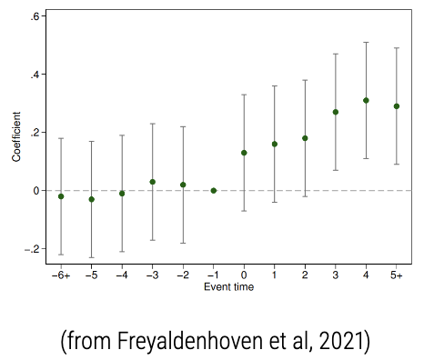

Dinas, E., Matakos, K., Xefteris, D., Hangartner, D. “Waking up the Golden Dawn: Does Exposure to the Refugee Crisis Increase Support for Exterme-Right Parties?” *Political Analysis,* 27, 244-254, 2019.

Instrumental Variables

1. We observe a variable, called the instrument, that **is correlated** with the outcome.
2. We assume the instrument **does** **not have a causal effect** on the outcome.
3. We assume the instrument **does have a causal effect** on the treatment.
4. We assume the instrument is **randomly assigne**d (or ‘as if’).
5. From step 4, the causal effect of the instrument on the treatment is their **correlation** in the data.
6. Since the instrument is **randomly assigned,** it is **not correlated** with any other possible confounder except the treatment.

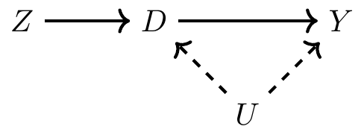

* Even though Z (instrument) is correlated with outcome (Y), we assume it is **non-causal,** so can remove line from Z to Y (STEP 2).
  + **https://www.youtube.com/watch?v=nsr9eh-qVPg**
* Even though Z (instrument) could be correlated with pre-treatment variables (confounders), because Z is randomly assigned, it can’t be causing pre-treatment variable changes (STEP 4). So, we can remove the line between Z and U.
* Leaves us with one possibility – that the instrument has an effect on outcome **through** the treatment variable. Any correlation we see between instrument and outcomemust be picking up on the **combined effect** of instrument on treatment and treatment on outcome.
* We need to now remove the effect of instrument on treatment. We do so, due to (STEP 5), by removing the correlation between the instrument and treatment, thus isolating the effect of treatment on outcome.

**Week 9: Lecture – Difference in Differences 2**

**Pre-Trend Testing (with Caution)**

Is of a lack statistically significant difference good evidence for the parallel trends assumption?

* In cases where there is a small deviation in trends but its not statistically significant
  + 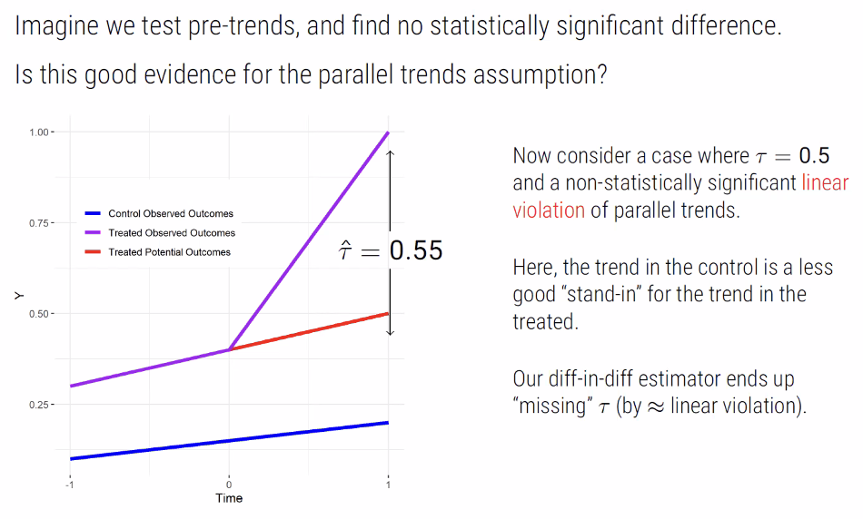
  + In above, estimator (Tau) slightly overestimates non-observed difference in potential outcomes.
* Now, consider a non-statistically signiifcnat linear violation of parallel trends – the difference in parallel trends is niow non-zero pre and post and increasing in post-period time.
  + So, if you were to extend over many time periods then the actual linear violation would be bigger than our estimation of Tau.
  + Bias = 0.05
* For which of these two differences are you more likely to reject the null hypothesis of no difference from zero? Bias = 0.05 or Tau = 0.55 (overestimation)
  + Both tests are equivalently powered by number of observations, but the point estimate for tau is much bigger and so bias is less likely to be rejected.
  + We are likely to accept a study on basis on pre-trend test, be happy with SS treatment effect, but bias projects out over time.
  + We tend to then slelect samples that ‘pass’ our pre-trend tests but that are bad for post-trend.
* Can we calculate the Minimum Detectable Effect (MDE)?

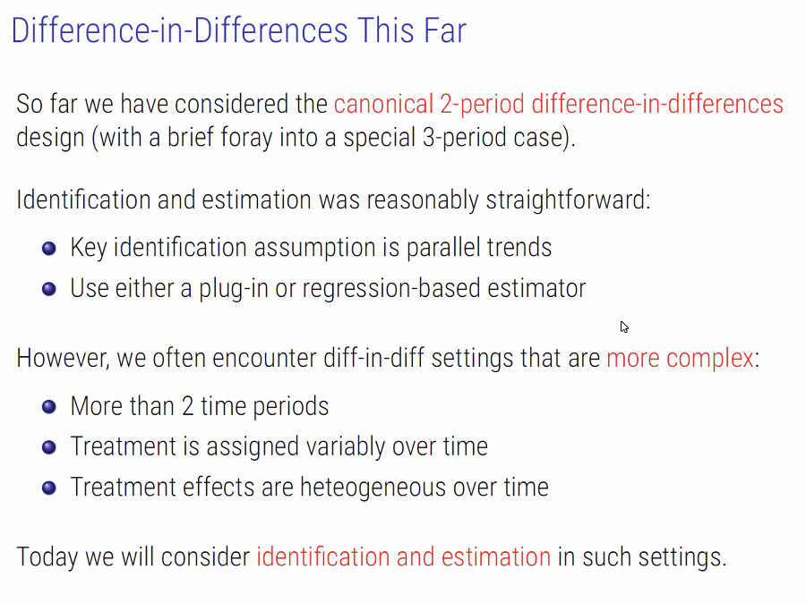

What about if:

* We have more than two time periods (pre/post)?
* We have heterogenous treatment effects?
* We want to generalise much more?

**Fixed Effects Estimation**

* For unit i, we observe T values (time periods) of Y. We should this in a vector format.
* For unit i, in we have a set of vectors for all values of each X variable for each value of T, which basically looks like a vector.
* So, if you want to know about the 5th obseration
  + You look at Yi5
  + You look at Xi5

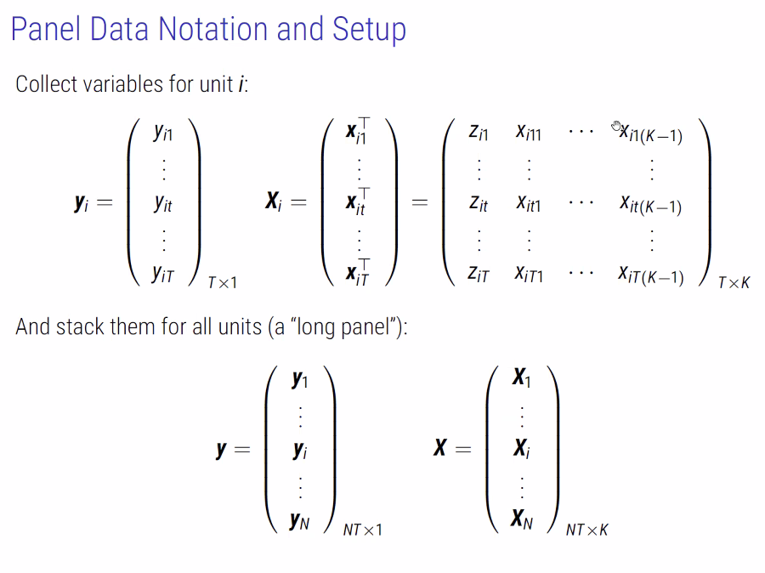

* In our ‘Long Panel,’
* We’ll have a giant matrix of N * T * K for X,
* And a set long vector of N * T for Y.

**Fixed Effects Estimators**

**Methods**

1. Beta-hat can be obtained via first differences estimation:
   1. We take the first difference (between t and t-1)
   2. Regress Change in Y-it on Change in X-it
   3. By taking the first difference we ‘purge’ the fixed effects alpha-i.
2. Can also be obtained via within estimation:
   1. Create de-meaned variables
   2. Regress demeaned y-it on x-it.
   3. By within-demeaning we purge the fixed effects alpha-i.
3. Or, with Least Squares Dummy Variable (LSDV) estimation:
   1. Regression X-it on Y-it and unit dummies
   2. Here, we directly estimate alpha-I with no purging.

If you get significantly different estimates via different methods then we have a more fundamental problem.

**Assumptions**

1. Strict exogeneity conditional on the unobserved effect.
   1. A typical violation comes from common shocks that affect all units of y-it in the same way and are correlated with x-it.
   2. Common shocks that affect all units y-it in the same way and are corelated with x-it.
      1. Such as trends in technologies, immigration flows, recessions, etc.
2. No carryover effects
   1. Treatment status for any Z-it does not directly affect outcome Y-I,t > t.
3. Rank Condition
   1. Has to be variation in regressors

**Time Fixed Effects**

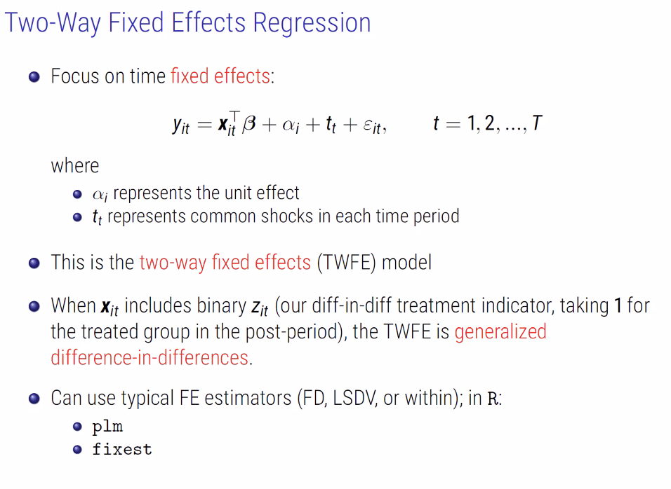

**Variable Treatment Timing (Two-way-treatment-effect)**

Multi-period diff-in-diff has one of three treatment riming regimes:

* Uniform,
* Staggered,
* Non-staggered

**TWFE with treatment at multi stages**

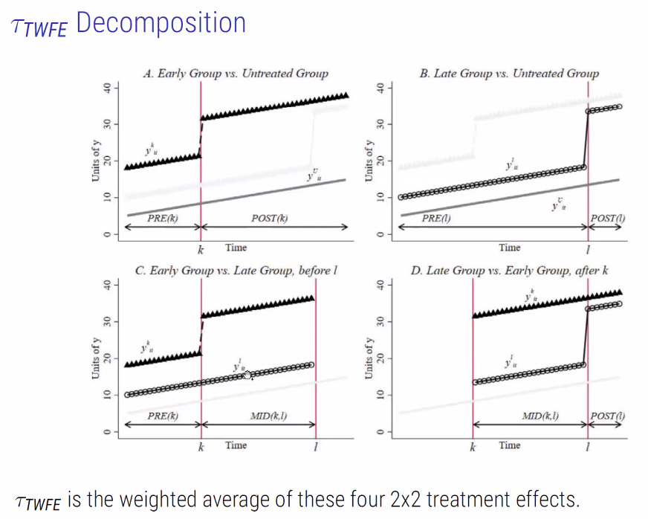

In bottom right, we’re dealing with treated at late stage versus. A group that has ALREADY been treated.

* The set of treated units that were treated first don’t go through a second round of treatment.

TWFE Is the weighted average of these four 2x2 treatment effects.

* Negative weights can arise where already treated units are used as controls after they are treated.

This decomposition reveals the assumption under which traditional TWFE might be trusted with multi-period panel data and a diff-in-diff design.

A causal diff-in-diff interpretation requires either:

1. Parallel trends with constant treatment effects over time, or,
2. Parallel trends with uniform timing (implies constant tau over time)

**Estimators for Multi-period diff-in-diff studies with homogenous effects**

Multi-period diff-in-diff with non-uniform (staggered or non-staggered) treatment timing should be approached with caution!

Two general types of modern estimators than can help:

1. Flexible matching and re-weighting estimators:
   1. Make the ‘right’ comparisons only.
   2. Weight appropriately and recover Tau-ATE.
   3. We focus on Callaway and Sant’Anna (2021)
2. Counterfactual estimators:
   1. Intuition: Problem we are encountering is we’re using all our data to impute missing counterfactuals for both the treated AND the controls.
      1. Because we’re not making a distinction between what we’re trying to predict, we’re just predicting Y.
      2. Let’s actually just assume that all potential outcomes under treatment (Y0-1) are missing data.
         1. We focus instead exclusively on estimating Y0 by using pre-treatment data. What should potential outcome under control actually look like?
         2. Means we don’t make forbidden comparisons!
   2. We will focus on Liu, Wang & Xu (2022).

**Callaway & Sant’Anna (2021) Setup:**

* C&S study a diff-in-diff with multiple time periods, staggered treatment timing, there may be homogenous tau, and parallel trends may hold only conditional on X.
* Begin by defining a new estimands, the group-time ATT:

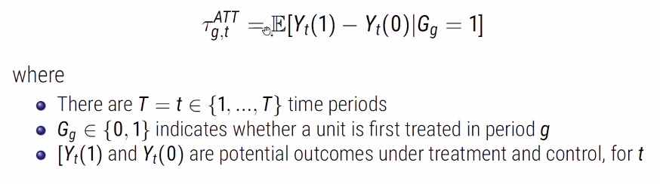

**Identification**

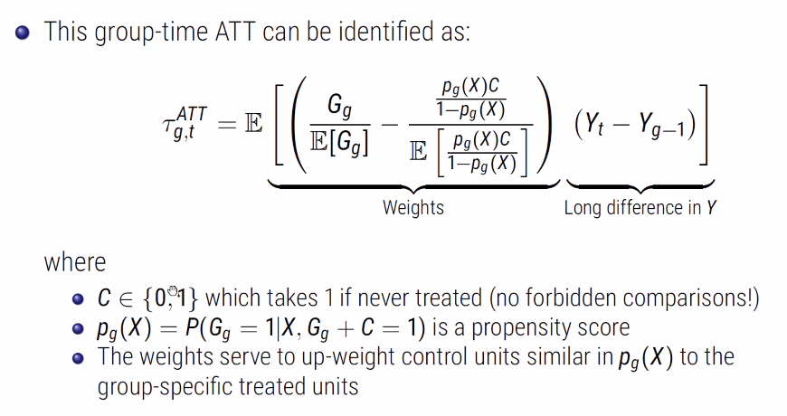

**Liu, Wang, and Xu (2022): Setup**

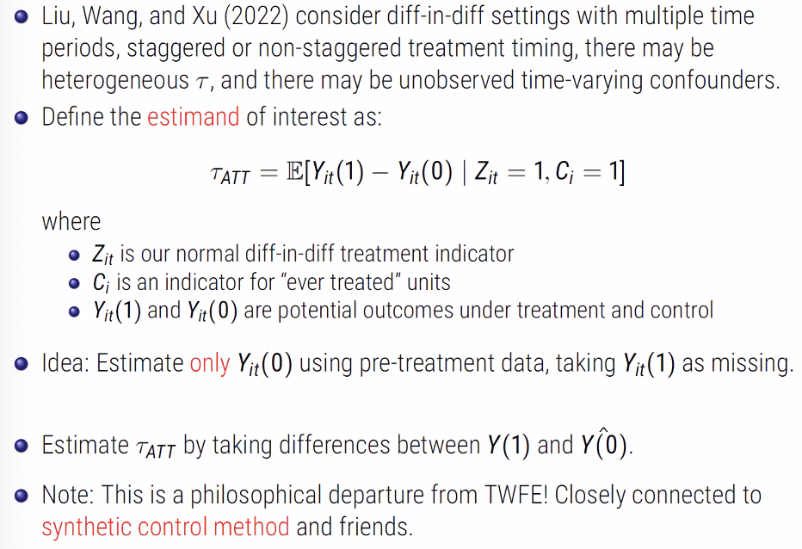

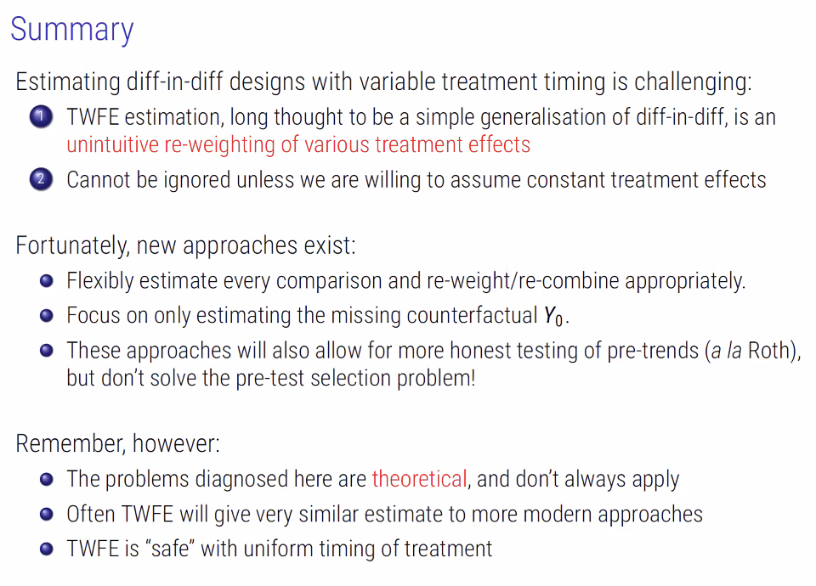

**Thistlewaite, D., Campbell, D. “Regression-Discontinuity Analysis: An Alternative to the Ex-Post Facto Experiment,” *Observational Studies,* 3(2), 2017, 119-128.**

**Hansen, B. “Punishment and Deterrence: Evidence from Drunk Driving,” *American Economic Review,* 105(4), 1581-1617, 2015.**

* Why did Hansen choose 4 years after DUI as cutoff? Is this a form of p-hacking?
  + Chosen as it allows a sufficient time period for an individual to potentially re-offend after license suspension has ended.
* What are the assumptions that need to be met?
  + Underlying Conditional Regression and Distribution Functions
    - Both observables and unobservables are expected to remain unchanged across the threshold with only the treatment status changing.
      * Mcrary Test
      * Is this the case for Male in figure 2?
  + Eligibility index needs to be continuous around cutoff point.
  + Those on either side of cutoff should be similar across confounders.
* Design
  + Rectangular Kernel
* 1 if they are subjected to a test or refuse a test (not if they blow over BAC levels again)
  + But could they be stopped for behaviours that **mimic** drunk driving but are actually for something else?
    - E.g. are those who drive drunk more inclined to commit crimes that warrant a breathalyser?
* There is heterogeneity of recidivism.
  + Recidivating at higher BAC levels is more dangerous than at lower levels.
  + Those with at least 1 prior test are less likely to be pulled over and refuse a breath test.
    - More aware of severity of punishment associated with refusal?
* In summary, the estimates indicate that drivers with BAC over the 0.08 recidivate less, as do drivers with BAC over the 0.15 threshold. Having a BAC over either the 0.08 or 0.15 thresholds is associated with a decrease in future accidents particularly among offenders with prior DUI stops.
* The estimated reduction is largest in bost absolute magnitude and percentage terms in a 91 to 365 day window (for over 0.08).
* The estimated coefficients suggest the 0.15 threshold effect is largest in the 731 to 1460 day period.
* Over firs 2 years , having BAC over DUI threshold reduces reoffence by 30% for all potential offenders.

**Week 11: Instrumental Variables & Regression Discontinuity Design**

**Instrumental Variables**

Often, we cannot ensure compliance with treatment. Units choosing to take the treatment may differ in unobserved characteristics from units that refrain from doing so.

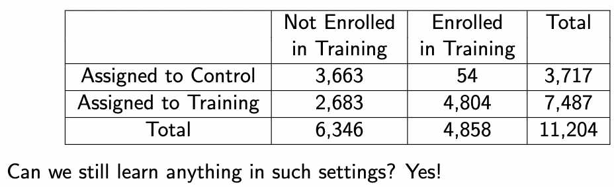

**Setup**

1. New variable Zi (either 0 or 1) is randomised encouragement.

2. Treatment as potential outcomes under Z: D1i, D0i.

- Dzi = 1: would receive the treatment if Zi = z.

- Dzi = 0: would not receive the treatment if Zi = z.

In a world of perfect compliance, treatment assignment is same as encouragement assignment. However, this often isn’t the case.

If D1i = 1, you were encouraged to take treatment and you actually did take the treatment.

Note: encouragement != treatment.

Observed treatment indicator **Di** is essentially the realised potential outcome for treatment assignment for Zi = z.

Thus, observed outcome of Yi can also be written as Yi = Yzi,i.

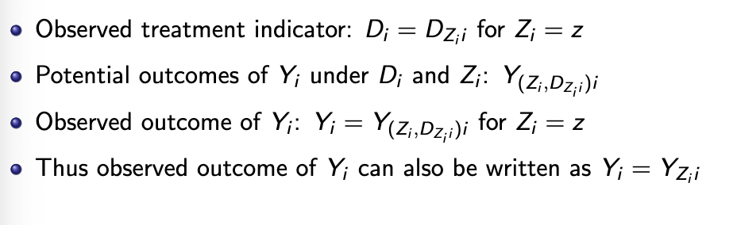

*Y is a function of Z through D in core IV setup.*

Given our setup, we can define four compliance types:

**Complier**

Unit I is a complier if D1i = 1 and D0i = 0. E.g., *if you what you’re told.*

**Non-Compliers**

*Always-takers:* Whether you encourage yes or no, they’re taking the treatment.

*Never-takers:* Whether you encourage yet or no, they’re never taking the treatment.

*Defiers:* The treatment assignment is oppositional to the encouragement. So, D1i = 0 and D0i = 1.

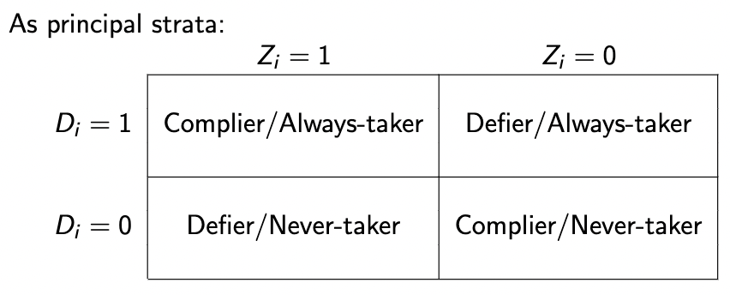

*This creates a problem for us. It means that we’re always going to struggle to properly identify any individual in our data as being any one of these groups.*

**New Causal Estimand: The ITT (Intention to Treat)**

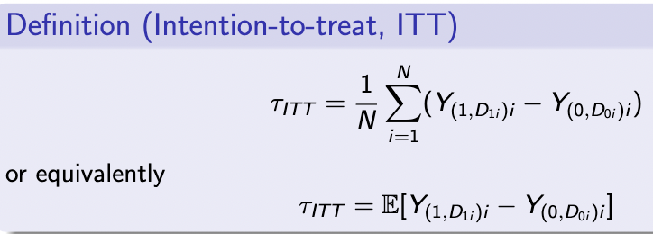

Effect of encouragement on outcome (regardless of treatment status). We cannot force all subject to take the (randomly) assignment treatment/control.

With self-selection into the treatment/control groups: Tau-ITT is not equal to Tau-ATE.

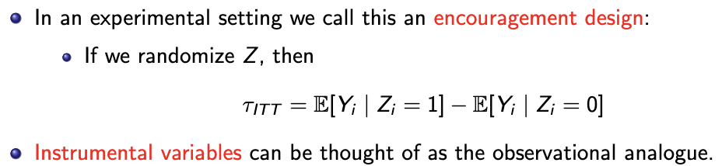

***The ITT only allows us to say something about the effect of Z on Y.***

*What about the effect of D? This is where IV can help.*

**IV Assumptions**

1. SUTVA

2. Exogeneity or ignorability of the instrument:

*1. Potential Outcomes of treatment need to be independent of Z. All of our compliance types are balanced across levels of Z.*

*2. Observed Outcome is independent of Z.*

3. Monotonicity: *D1 => D0 (“no defiers”)*

4. Exclusion Restriction: *Z only affects outcome* ***through treatment.***

5. Relevance of the instrument: *The probability of taking instrument needs to be bounded by 0 and 1, and the probability of treatment under Z =1 is not the same as Z = 0.*

Can also make these all conditional: Conditional on some set of covariates, we believe this to be true. This set of assumptions leads from the below:

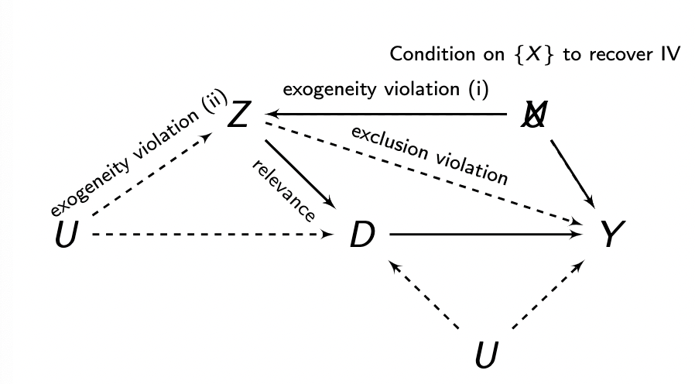

***To:***

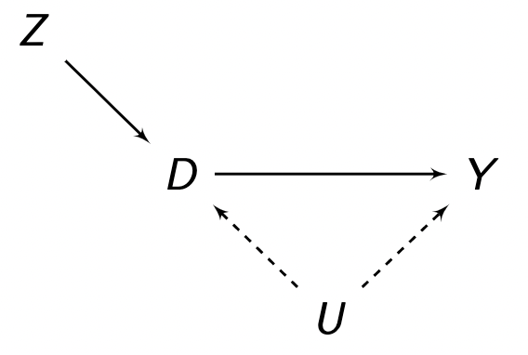

How? Conditioning on X blocks the back-door path of Z on Y.

Randomisation de-correlates Z and U.

The above two satisfies the exclusion restriction assumption.

In many cases, we need to *decompose* **Tau-ITT in** order to identify the different compliance groups so that we can make inferences about the effect of treatment on outcome, rather than the effect of encouragement on outcome.

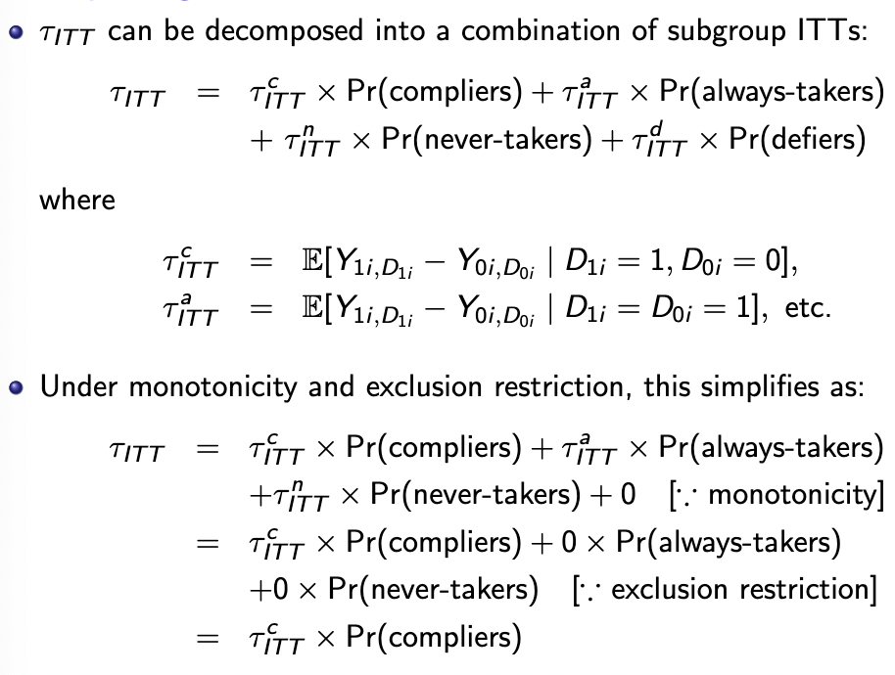

**Compliers,**

**Always-takers**

Now, under exclusion restriction, we know that the Tau-ITT = 0 as D is constant and thus difference between compliers & always/never takers is 0.

So, Tau-ITT = Tau-ITT-compliers * Proportion(compliers)

We can observe both Tau-ITT & Proportion(compliers) because we assume defiers away, and can identify always/never takers through data. Thus, we can identify the Tau-ITT-compliers as a result.

Tau-ITT-compliers can be interpreted as **Local Average Treatment Effect (LATE)** for compliers. It has a clear causal meaning:

* It’s the different in potential outcomes for compliers.
* We can never identify who the compliers actually are,
* Different encouragements (instruments) may yield different compliers.

A plug-jn estimator is called the Wald estimator:

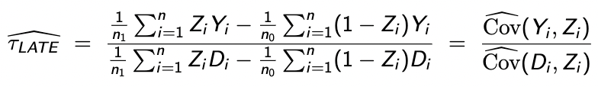

* The Wald estimator is consistent, but not unbiased in finite samples.
* The small sample bias may be considerable when the instrument is weak.
* This is an active area of debate – Stock & Yogo (2005), Lee et al. (2022), Angrist & Kolesár (2023).

Tau-LATE-hat can also be estimated via two-stage least squares (2SLS), a traditional instrumental variables method in econometrics.

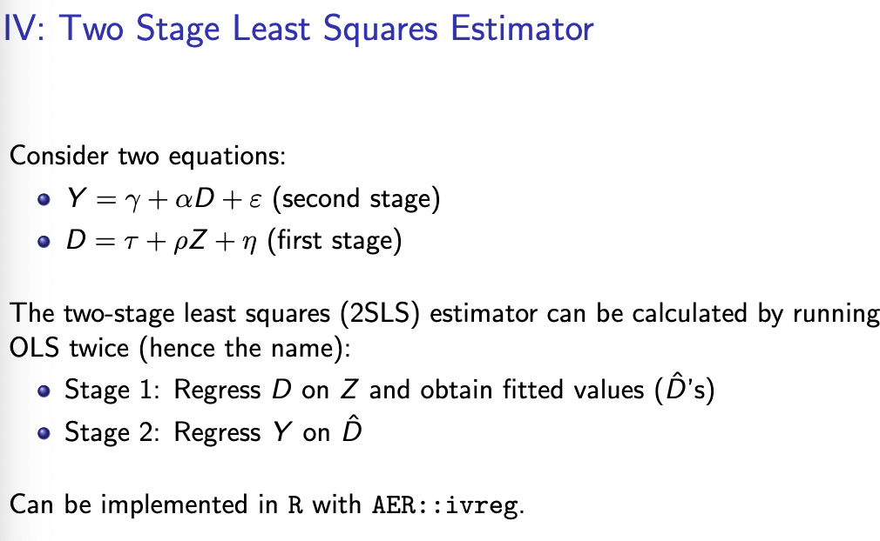

* First stage we regress D on Z. We are predicting D as a function of encouragement.
* At second stage, we are predicting Y with the fitted values of D.

**Regression Discontinuity Design**

**Sharp Regression Discontinuity Design**

**Setup**

* **Xi:** *Forcing variable that perfectly determines the value of Di with cutpoint c.*

*Threshold determines whether observation is in treatment group 1 or 0.*

*Xi may be correlated with Y0i and Y1i, either directly or via other unobserved confounders.*

*Simply adjusting for Xi does not work because of lack of common support.*

*Basic intuition: Right at the cutpoint Xi = c, assignment to Di may be considered as-if random.*

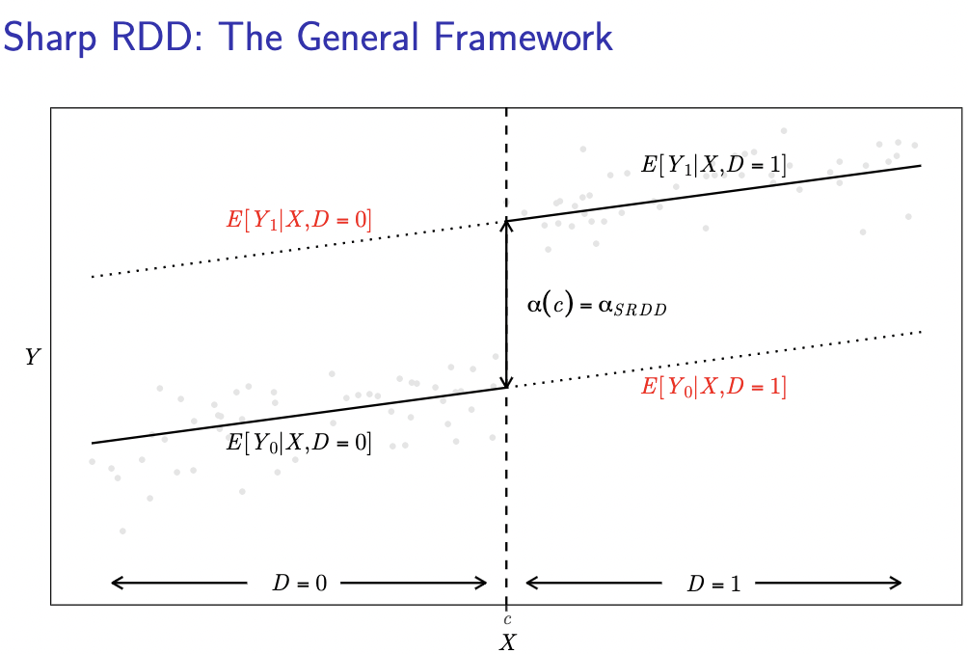

**Identification Assumptions**

* **Conditional Independence**

*Once you condition on X, you have independence between treatment and outcomes. In RDD, this is trivially satisfied as treatment is determined by X.*

* **Continuity Assumption**

*Our two potential outcomes are continuous around threshold. E.g., the regression line would have continued smoothly across the threshold.*

**Estimation Steps:**

* + - 1. **Train discontinuity sample**
      2. **Center the forcing variable as deviations from the threshold**
      3. **Decide on a model for E[Y|X]**

**Train discontinuity Sample**

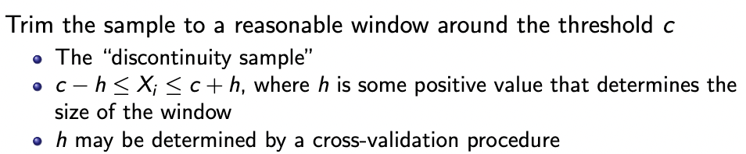

**Select Appropriate Bandwidth around threshold**

* Estimation in RDDs is essentially a prediction problem: we want to predict the unobserved value of Y when X = c.
* The bandwidth is a ‘tuning’ parameter that we should try to select in a non ad-hoc way.
* Choose h that minimises prediction error. We use cross-validation to do so by taking different sections of line as validation set.

**Center the forcing variable, as deviations from the threshold.**

* X-tilda = X – c. X-tilda = 0 is at the cutoff point.
* Define D as a function of our re-centred X.

**Decide on a model for E[Y|X]**

* linear, same slope for E[Y0i | Xi} and E[Y1i | Xi].

**We run a regression of Y on D and X-tilda = X – c**

* Linear, different slopes for E[Y0i | Xi} and E[Y1i | Xi].

**We run a regression of Y on X-tilda, D and the interaction X-tilda*D**

* Non-linear
* Always begin with visual inspection (scatters, kernel densities, LOESS smoothness, piecewise linear fits).

**Falsification Checks for Sharp RDD**

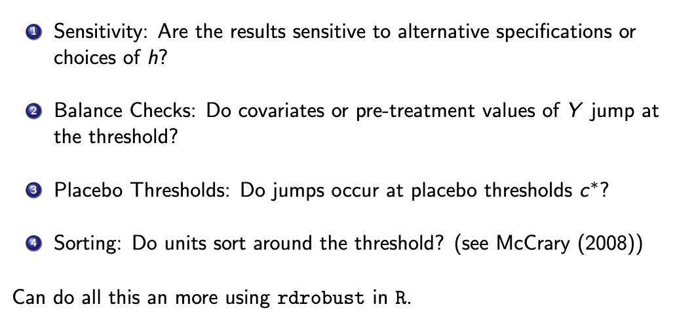

1. **What if we pretend that our threshold isn’t 50, but it’s 25?**
2. **Do units sort around the threshold? E.g., can subjects manipulate to land one side of the border.**

**Fuzzy Regression Discontinuity Design**

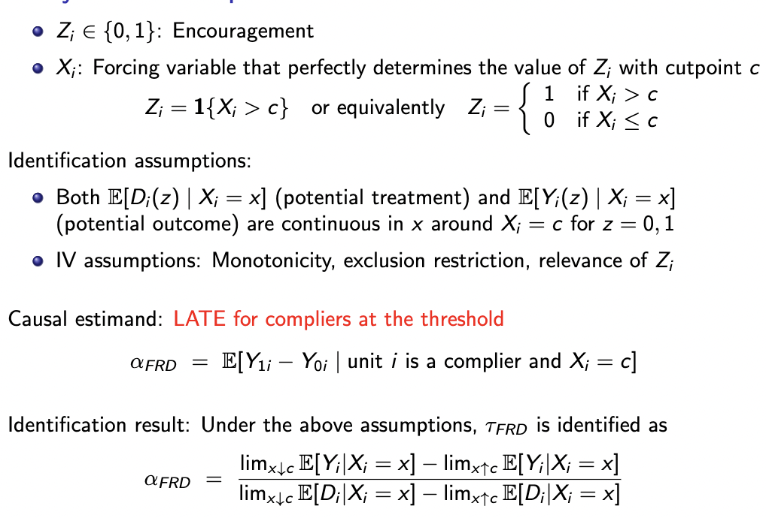

**Z is discontinuously defined as 1 or 0 on basis of cut-point Z. Then, D is a function of Z. In this case, it’s not treatment assignment that is discontinuous but the probability of treatment assignment is discontinuous, based on our encouragement demarcation line.**

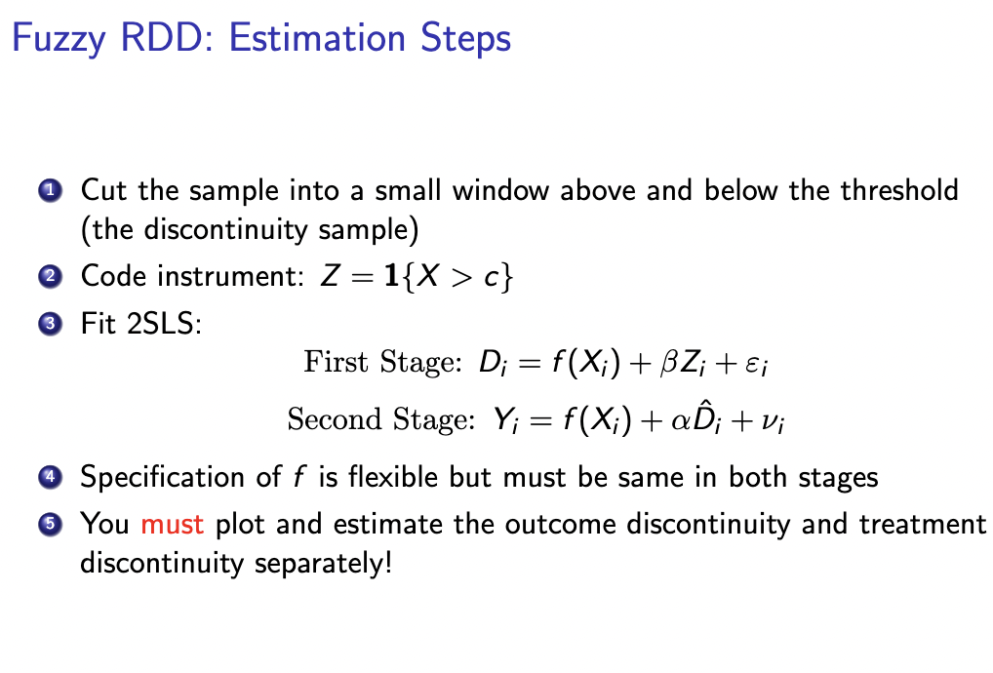

**We’re looking for the LATE for compliers at the threshold.**

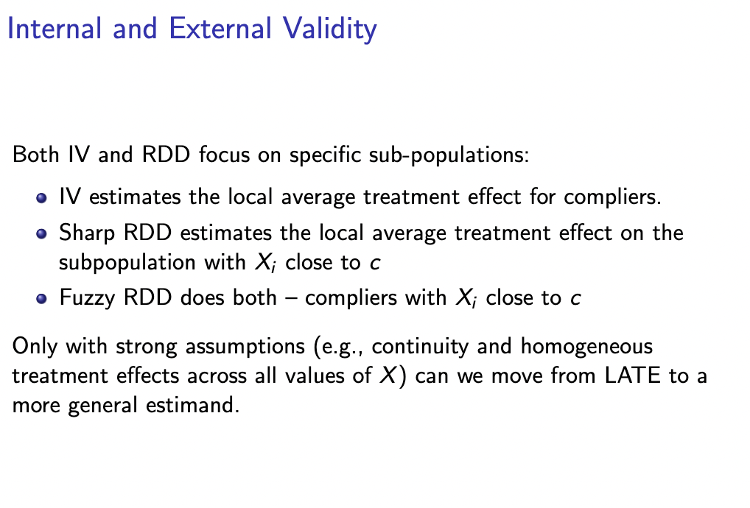

**MY457 Q&A**

* **Bring a calculator**